Table of Content

1. Project Introduction 5
2. Preliminary Analysis 6
   1. Limitations of the Present System 8
   2. Proposed System 10
   3. Feasibility Study 12
      1. Economic Feasibility 12
      2. Technical Feasibility 12
      3. Operational Feasibility 13
   4. Stakeholders 14
   5. Technologies Used 16
3. Module Description 18
   1. User Module 18
   2. Admin Module 18
   3. Landlord Module 19
4. System Design 21
   1. Use Case Diagram 21
   2. Class Diagram 22
   3. Activity Diagram 23
   4. Sequence Diagram 24
5. Test Case 67
6. Reports…………………………………………………………………………………….70
7. UI Screen Shots 72
8. Future Scope 80
9. Conclusion 82
10. Bibliography .84

# Project Introduction

Introducing "RentEase" - The Ultimate House Rental App

RentEase, the definitive solution for all your house rental needs, serves both tenants on the quest for their perfect homes and property owners in search of reliable renters. This groundbreaking platform redefines property management, making it not only efficient but also accessible to all parties involved.

**Effortless Property Search:** The task of finding the ideal rental property can often seem like a daunting endeavor, but RentEase transforms it into a seamless experience. The app boasts an extensive database of rental properties, ranging from cozy apartments to spacious houses and upscale condos. Its user-friendly interface ensures that users can effortlessly navigate through these options, guaranteeing they discover accommodations that perfectly align with their preferences and requirements.

**For Tenants:** RentEase offers tenants an experience that's not only transparent but also streamlined. Once users identify a property of interest, they can dive into comprehensive listings featuring high-resolution photos, virtual tours, and detailed property descriptions. The app simplifies the process of scheduling viewings, engaging in direct communication with property owners or managers, and submitting rental applications—all within a secure and integrated platform. Rest assured, RentEase takes privacy seriously, safeguarding personal information while facilitating seamless communication.

**For Property Owners:** Managing rental properties has never been easier. RentEase simplifies the entire process, saving property owners precious time and effort. Property owners can effortlessly create and manage listings, effectively showcasing their property's unique features through uploaded photos to attract potential tenants. The app also empowers property owners to receive and review rental applications, conduct background checks, and communicate with prospective renters—all within a seamless and integrated platform. Additionally, RentEase offers secure payment processing, making it convenient to collect rent and handle financial transactions with unwavering confidence.

RentEase is steadfast in its mission to create a seamless and secure rental experience for all parties involved. The ultimate goal is to simplify the rental process while providing greater control over housing needs. RentEase stands as the unequivocal solution for those seeking a hassle-free rental experience.

# Preliminary Analysis

RentEase is not just another mobile application; it represents a visionary project that seeks to redefine the way individuals engage with the ever-evolving house rental market. Our core mission is to craft a user-centric platform that reimagines and enhances the entire house rental experience, placing accessibility, security, and efficiency at the forefront. Beyond the conventional rental features that most platforms offer, RentEase aims to integrate advanced functionalities that encompass robust user authentication, dynamic property listing management, effective communication tools, streamlined rental application processes, secure payment solutions, and responsive user support.

Our journey commences with an in-depth analysis of the housing market, revealing a compelling demand for a comprehensive house rental application. This demand is fueled by several key factors, including shifting housing trends characterized by a burgeoning population of renters. In today's fast-paced world, consumers prioritize convenience, security, and trust in their rental transactions. Furthermore, the omnipresence of mobile applications in modern life underscores the need for a dedicated, feature-rich app tailored specifically to the intricate world of house rentals.

RentEase is poised to introduce a suite of key features within the application, each meticulously designed to cater to the diverse needs of both tenants and landlords. For tenants, the application provides a seamless and transparent rental experience. It empowers them to explore detailed listings, schedule viewings, communicate directly with property owners or managers, and securely submit rental applications. Privacy is paramount, and RentEase ensures that personal information remains protected throughout the process.

For property owners, RentEase streamlines the property management process, allowing them to create and manage listings with ease, conduct background checks, receive and review rental applications, and securely manage financial transactions. The platform also offers a secure payment processing system, simplifying the collection of rent and financial management.

RentEase relies on cutting-edge technologies such as Flutter, Dart, Node.js, Express, and SQLite3 to create a robust and scalable foundation. These technologies have been meticulously chosen to ensure that the platform not only withstands the test of time but also accommodates growth and efficiently manages data.

To further enhance the project's prospects for success, we will conduct a comprehensive feasibility study. This study will meticulously assess the technical, operational, and financial aspects, providing us with invaluable insights into potential challenges, risks, and opportunities. It ensures a well-informed approach to development and launch.

Our stakeholders encompass a diverse group, including tenants, landlords, our dedicated development and technical team, investors, financial supporters, and regulatory authorities responsible for overseeing compliance with local housing and rental regulations.

In conclusion, RentEase stands poised to revolutionize the house rental market by offering a secure, convenient, and innovative platform. Through meticulous planning, a thorough feasibility study, and an unwavering commitment to meeting user needs, RentEase aspires to become a prominent player in the realm of house rental platforms. By simplifying the rental process and enhancing accessibility, RentEase seeks to elevate the experiences of tenants and landlords alike in the dynamic world of house rentals. Our journey is marked by a commitment to innovation, efficiency, and user satisfaction, making RentEase more than just an app; it's a transformative force in the rental market.

## Limitations of the Present System

House rental apps, though popular, have certain limitations that have prompted the development of RentEase, a new house rental app. In this section, we will delve into these limitations, addressing aspects such as user experience, data management, features, and more.

1. User Experience:

House rental apps often suffer from complex user interfaces and navigation, making it challenging for users to find and secure suitable rental properties. The search and filtering options may not be intuitive, resulting in a frustrating user experience. Furthermore, communication with property owners or managers can be cumbersome.

2. Limited Property Listings:

Many house rental apps have a limited inventory of available properties. Users may find that the app does not cover a broad geographic area or lacks listings in specific neighborhoods. This limitation restricts users' choices and may lead to missed opportunities.

3. Data Management:

Users often face difficulties in managing their rental history and lease agreements within house rental apps. These apps may not provide effective tools for storing and organizing essential documents and information related to their rental properties, leading to a cluttered and disorganized experience.

4. Lack of Customization:

Some house rental apps lack customization options for user profiles and preferences. Users may not be able to personalize their search criteria adequately, resulting in recommendations and property listings that do not align with their specific needs and preferences.

5. Transaction Handling:

Handling rental transactions, including rent payments, security deposits, and lease renewals, can be challenging within some apps. Users may find it cumbersome to manage financial aspects of their rental agreements, leading to potential confusion and payment delays.

6. Limited Communication Features:

Communication features within house rental apps may be limited, hindering effective interaction between tenants and property owners or managers. Users may face difficulties in scheduling property viewings, reporting maintenance issues, or resolving disputes within the app.

7. Inadequate Tenant Screening:

Some apps do not provide comprehensive tenant screening tools for property owners and managers. This limitation may result in challenges in selecting reliable tenants, potentially leading to issues with rental payments and property maintenance.

8. Integration Challenges:

Integrating with other services, such as property management software or payment gateways, can be cumbersome within certain house rental apps. This limitation affects workflow automation and can result in manual data entry and repetitive tasks for users.

9. Security:

Security concerns, including data privacy and protection, can be a significant limitation. Users may worry about the safety of their personal and financial information within the app, leading to trust issues.

These limitations highlight the need for a comprehensive and user-friendly house rental app like RentEase. By addressing these challenges and offering a more streamlined and feature-rich platform, RentEase aims to provide an enhanced house rental experience for both property seekers and landlords, improving efficiency and convenience in the rental process.

## Proposed System

RentEase is poised to be a groundbreaking house rental app that stands as a solution to the limitations encountered in existing rental platforms. The proposed system aims to reimagine the way users search for rental properties, interact with property owners and managers, and manage their rental journey. It is designed with a holistic approach to prioritize user experience, data management, and seamless communication.

1. User-Centric Design:

RentEase's commitment to user experience starts with a user-centric design philosophy. The proposed system meticulously crafts its user interface to be not only visually appealing but also highly intuitive. Every element on the screen is thoughtfully placed to optimize usability. This design approach ensures that users, regardless of their technological proficiency, can navigate the app effortlessly. The menus are streamlined, and calls to action are clear, providing an accessible and enjoyable experience. It focuses on minimizing the learning curve, making the app welcoming and efficient for everyone.

2. Intuitive Search and Filtering:

The proposed system elevates the search and filtering functionalities to a new level of intuitiveness and effectiveness. RentEase employs advanced algorithms that delve into user preferences, location, budget, and property features to provide tailored search results. A user-friendly filter system is a cornerstone of this approach. Users can refine their searches with ease, ensuring they find properties that align perfectly with their needs. Furthermore, intelligent recommendations based on user behavior enhance the house-hunting journey, presenting users with properties they might have otherwise overlooked.

4. Comprehensive User Guidance:

RentEase is dedicated to providing users with comprehensive and standardized guidance throughout their rental process. Whether users are submitting rental applications or seeking to understand complex lease agreements, the proposed system offers clear explanations and step-by-step instructions. Access to a wealth of resources, including FAQs, video tutorials, and legal guides, empowers users to navigate every stage of their rental journey with confidence. This commitment to user guidance minimizes confusion, reduces errors, and ensures users are well-informed every step of the way.

5. Mobile Responsiveness and Accessibility:

The proposed system recognizes the significance of mobile accessibility in the modern age. RentEase is meticulously optimized to provide users with a consistent and smooth experience, regardless of their chosen device. The system prioritizes mobile responsiveness, with a focus on fast loading times, user-friendly touch interfaces, and seamless transitions between devices. This ensures that users can access RentEase with the same efficiency and comfort whether they are using smartphones, tablets, or desktops.

6. Data Management Excellence:

RentEase's commitment to data management excellence sets it apart. The proposed system offers users the ability to effortlessly organize and store their rental history, lease agreements, and essential documents within the app. It leverages advanced cloud-based storage solutions that prioritize data security, accessibility, and reliability. Users can also harness the power of robust data analytics tools, which provide valuable insights into their rental portfolios. These insights enable informed decision-making and optimized property management, ensuring that RentEase isn't just about finding rental properties but also effectively managing them.

In conclusion, the proposed system for RentEase is more than a house rental app; it is a transformative platform that reimagines the house-hunting and property management experience. By championing user experience, intuitive search and filtering, efficient communication, comprehensive user guidance, mobile accessibility, and data management excellence, RentEase aims to set a new standard in the industry. The proposed system is driven by a deep commitment to deliver convenience, empowerment, and peace of mind to both house hunters and property owners. This vision makes RentEase the preferred choice for all rental needs, marking a significant leap forward in the rental platform landscape.

This extended description provides a more comprehensive view of how RentEase intends to reshape the rental platform landscape, prioritizing user experience, data management, and seamless communication for all users.

## Feasibility Study

**2.3.1 Economic Feasibility:**

The economic feasibility study for RentEase involves assessing the financial viability of the proposed rental property app. The following key considerations are taken into account:

* Market Analysis: Thorough market research is conducted to understand the demand for rental properties in the target locations. This includes analyzing rental trends, vacancy rates, and the preferences of potential renters. Understanding the competition in the market and identifying gaps that RentEase can fill is essential to determine the app's market potential.
* Revenue Generation: Several revenue generation strategies are explored to ensure the app can sustain itself financially. This may include charging landlords a fee for listing their properties on the platform or offering premium features for a subscription fee. Additionally, RentEase may consider partnerships with real estate agents or property management companies for a commission on successful rental agreements facilitated through the app.
* Cost Analysis: A detailed cost analysis is conducted to determine the expenses associated with app development, maintenance, and operations. This includes software development costs, server hosting, marketing, customer support, and any other ongoing expenses. The goal is to identify cost-effective solutions and budget constraints while maintaining the app's quality and user experience.
* Return on Investment (ROI) Analysis: The ROI is calculated to estimate the app's profitability over time. This involves comparing the projected revenue with the total investment to determine if the app can generate a positive ROI within a reasonable timeframe.

**2.3.2 Technical Feasibility:**

The technical feasibility study for RentEase involves evaluating the app's technical requirements and capabilities. Key considerations include:

* Technology Evaluation: Assessing the suitability of technologies such as React Native or Flutter for developing a cross-platform mobile app. Evaluating the scalability of the chosen technology to handle an increasing number of users and property listings is crucial.
* Resource Availability: Ensuring that the necessary technical expertise and resources are available to develop and maintain the app. This includes hiring skilled developers, designers, and potentially outsourcing certain tasks if required.
* Stakeholder Engagement: Involving potential users, landlords, and property managers in the technical feasibility study to gather feedback on their needs and preferences. This input helps shape the app's features and functionality to ensure it meets the expectations of its target audience.
* Data Security and Privacy: Ensuring that the app complies with data protection regulations and implements robust security measures to protect user data and transactions.

**2.3.3 Operational Feasibility:**

The operational feasibility study for RentEase involves evaluating the practicality of implementing and running the app. Key considerations include:

* User Engagement: Understanding how potential users will interact with the app and ensuring that it is user-friendly and intuitive. Conducting usability testing and gathering feedback from users during the development process is essential.
* Scalability and Performance: Assessing whether the app's infrastructure can handle a growing user base and increasing property listings without compromising on performance and responsiveness.
* Stakeholder Support: Ensuring that landlords, property managers, and renters are willing to adopt the app and actively use it for their rental needs.
* Legal and Regulatory Compliance: Ensuring that the app complies with all relevant laws and regulations related to rental property transactions, data protection, and user rights.

## Stakeholders

Stakeholders play a crucial role in shaping the vision, development, and success of RentEase. Identifying and engaging with these stakeholders is an essential aspect of the preliminary investigation to ensure alignment with goals and expectations.

**1. Primary Stakeholders:**

Primary stakeholders are individuals or groups who have a direct and immediate interest in the development and success of RentEase. They include:

- Development Team: The development team is at the core of RentEase's creation. This group of software engineers, designers, and project managers is responsible for bringing the app to life. Their technical expertise, creativity, and dedication are pivotal to the app's development and functionality.

- Investors: Investors provide crucial funding and financial support for RentEase. Their interests lie in the app's profitability and long-term sustainability. They may also contribute strategic guidance and business expertise to ensure a return on investment.

- Users: Users are the lifeblood of RentEase. They encompass property seekers (tenants) and property owners or managers (landlords). Users directly benefit from the app's features and usability, making their feedback and satisfaction vital for RentEase's success.

**2. Secondary Stakeholders:**

Secondary stakeholders are entities or groups that are indirectly affected by or have an influence on RentEase's development and implementation. They include:.

- Industry Associations: Associations related to the real estate and rental industry may influence industry standards and practices. Collaborating with or obtaining insights from these associations can be valuable for RentEase.

-Business Partners: Business partners, such as payment gateway providers or property listing websites, can impact RentEase's functionality and reach. Integration partnerships with these entities may enhance the app's features and accessibility.

**3. Stakeholder Roles:**

Clearly defined roles and responsibilities for each stakeholder group are essential to ensure effective collaboration and communication throughout the development and implementation of RentEase:

- Development Team: Responsible for app design, coding, testing, and ongoing maintenance, ensuring that RentEase operates smoothly.

- Investors: Provide financial support, strategic guidance, and resources to facilitate app development and growth.

- Users: Actively engage with the app, utilizing its features for property management, search, and rental transactions.

- Industry Associations: Offer insights, networking opportunities, and guidance on industry best practices.

- Business Partners: Collaborate to enhance RentEase's functionality through integrations, expanding its utility and reach.

**4. Stakeholder Engagement:**

Active and ongoing engagement with stakeholders is critical throughout the development and implementation phases of RentEase:

- Development Team: Regular meetings, feedback sessions, and collaborative discussions to ensure alignment with project goals and milestones.

- Investors: Periodic updates on progress, financial reports, and strategic discussions to maintain transparency and secure continued support.

- Users: Continuous communication channels for feedback, support requests, and feature suggestions to enhance user experience.

- Industry Associations: Participation in industry events, sharing insights, and seeking guidance on market trends and practices.

- Business Partners: Ongoing collaboration to establish and maintain integration partnerships, expanding RentEase's capabilities.

This comprehensive overview identifies the key stakeholders involved in the preliminary investigation of RentEase and their respective roles and engagement strategies. Stakeholder engagement is integral to ensuring that RentEase aligns with expectations and achieves its objectives effectively.

## Technologies Used

The preliminary investigation of RentEase relies on a suite of cutting-edge technologies to assess its feasibility and develop a clear understanding of its potential. Leveraging a diverse set of tools, languages, and platforms, the investigation lays the foundation for RentEase's future development and implementation.

**1. Flutter:**

Flutter, an open-source UI software development kit, plays a pivotal role in RentEase's preliminary investigation. This versatile framework is employed for creating RentEase's user-friendly and visually appealing mobile app interface. Flutter's cross-platform capabilities ensure that RentEase is accessible across various mobile devices, simplifying development and ensuring a consistent user experience.

**2. Dart:**

Dart, the programming language powering Flutter, is at the core of RentEase's mobile app development. Dart's robustness, speed, and support for modern programming features facilitate the creation of RentEase's app logic and functionality. It allows for efficient communication between the app's front-end and back-end components.

**3. Node.js:**

Node.js, known for its non-blocking, event-driven architecture, is chosen to power RentEase's server-side logic. Node.js efficiently handles concurrent requests, making it well-suited for real-time interactions and communication within the app. It plays a critical role in managing user data, facilitating smooth communication, and handling app security.

**4. Express:**

Express, a minimalist web application framework for Node.js, is utilized to streamline the development of RentEase's server-side components. Its simplicity and robust routing capabilities help create RESTful APIs that enable seamless interaction between the mobile app and the back-end server.

**5. SQLite3:**

SQLite3 is employed as the database management system for RentEase's preliminary investigation. Its lightweight, serverless, and self-contained nature makes it a suitable choice for the early stages of development and feasibility assessment. SQLite3 is used to store and manage user data, ensuring data integrity and accessibility.

**6. Additional Tools and Technologies:**

In addition to the core technologies mentioned above, several other tools and technologies are employed to support the preliminary investigation:

- Version Control (e.g., Git): Version control systems are used to manage and track changes in RentEase's codebase, ensuring collaboration among team members and code integrity.

- APIs and Web Services: Integration with external services and APIs is explored to gather data, enhance functionality, and assess potential partnerships for RentEase.

- Data Analytics Tools: Tools for data analysis and visualization help in understanding user behavior and preferences, contributing to RentEase's feasibility assessment.

The technologies employed in the preliminary investigation of RentEase form a robust foundation for assessing its feasibility and potential. By leveraging Flutter, Dart, Node.js, Express, SQLite3, and a suite of supporting tools and technologies, the investigation explores the capabilities and limitations of RentEase while paving the way for its future development and implementation.

This comprehensive overview highlights the technologies used in the preliminary investigation of RentEase, showcasing how each technology contributes to the assessment and development of the proposed rental management system.

# Module Description

**User Module:**

1. User Registration and Login:

- Users can sign up with essential details like name, email, and password.

- Users may also have the option to sign up using their social media accounts for a quicker registration process.

- Registered users can log in using their credentials.

2. Create and Manage Rental Profiles:

- Users can create their rental profiles, specifying their preferences such as location, budget, property type, and other essential details.

- Users can edit and manage their rental profiles based on changing requirements.

3. Search and View Rental Listings:

- Users can search for rental properties based on their preferences, using filters such as location, rent range, property type, and amenities.

- Users can view detailed information about rental listings, including property photos, descriptions, and contact information for landlords.

4. Save Favourite Listings:

- Users can save their favourite rental listings to a personalized "Favourites" for future reference.

6. Apply for Rental Properties:

- Users can submit rental applications to landlords through the app, providing necessary documents and details for consideration.

9. Assistance and Support:

- Users can access customer support through the app to address any issues or queries related to their rental process.

**Admin Module:**

1. Admin Login:

- Admins log in using their credentials to access the admin panel.

2. User and Property Listing Management:

- Admins oversee user registrations, rental profiles, and property listings to ensure accuracy and compliance with platform guidelines.

- Admins have the authority to approve or disapprove property listings based on verification of property details.

4. Dispute Resolution:

- Admins mediate and resolve disputes between users and landlords, ensuring fair and transparent resolutions.

5. Platform Maintenance and Security:

- Admins ensure the overall stability, security, and maintenance of the app, including software updates and server management.

6. User Support:

- Admins provide support to users and address any technical or operational issues they may encounter.

7. Landlord Verification:

- Admins perform thorough verification checks on landlords to ensure their credibility and legitimacy.

8. Performance Analytics:

- Admins can access performance analytics, including user engagement, rental property popularity, and other key metrics to optimize the platform's performance.

**Landlord Module:**

1. Landlord Registration and Login:

- Landlords can sign up with essential details like name, email, and password to create their accounts.

- Landlords may also have the option to sign up using their social media accounts for a quicker registration process.

- Registered landlords can log in using their credentials.

2. Property Listing Management:

- Landlords can create and manage their property listings, providing detailed information, photos, and rental terms.

- Landlords can update or remove listings as per property availability.

3. Review Rental Applications:

- Landlords can review rental applications submitted by users and communicate with potential tenants through the app.

6. Rental Agreement and Documentation:

- Landlords can facilitate the rental agreement process, sharing necessary documents and terms with tenants.

7. Rental Payment Management:

- Landlords can manage rental payments, view payment history, and send payment reminders to tenants.

10. Assistance and Support:

- Landlords can access customer support through the app for any queries or assistance needed during the rental process.

# System Design

## Use Case Diagram

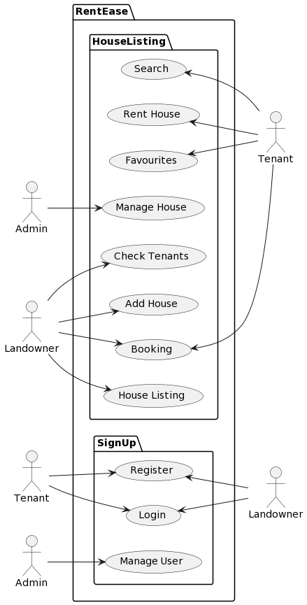

## Class Diagram

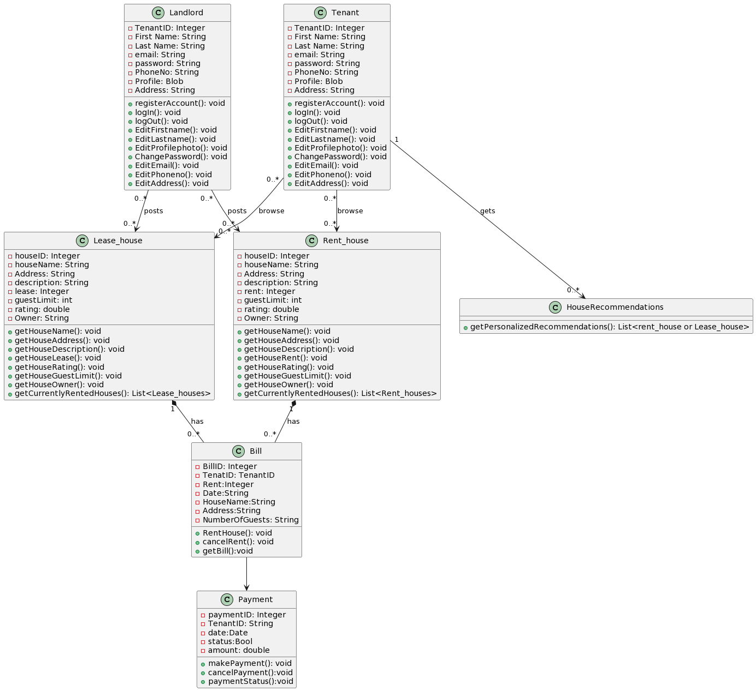

## Activity Diagram

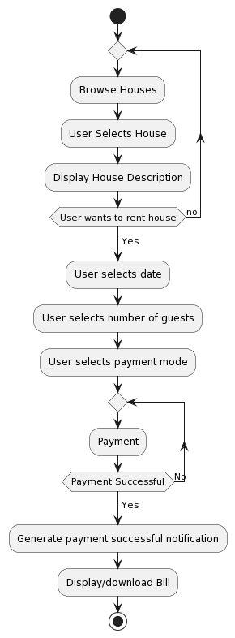

* + **Sequence Diagram**

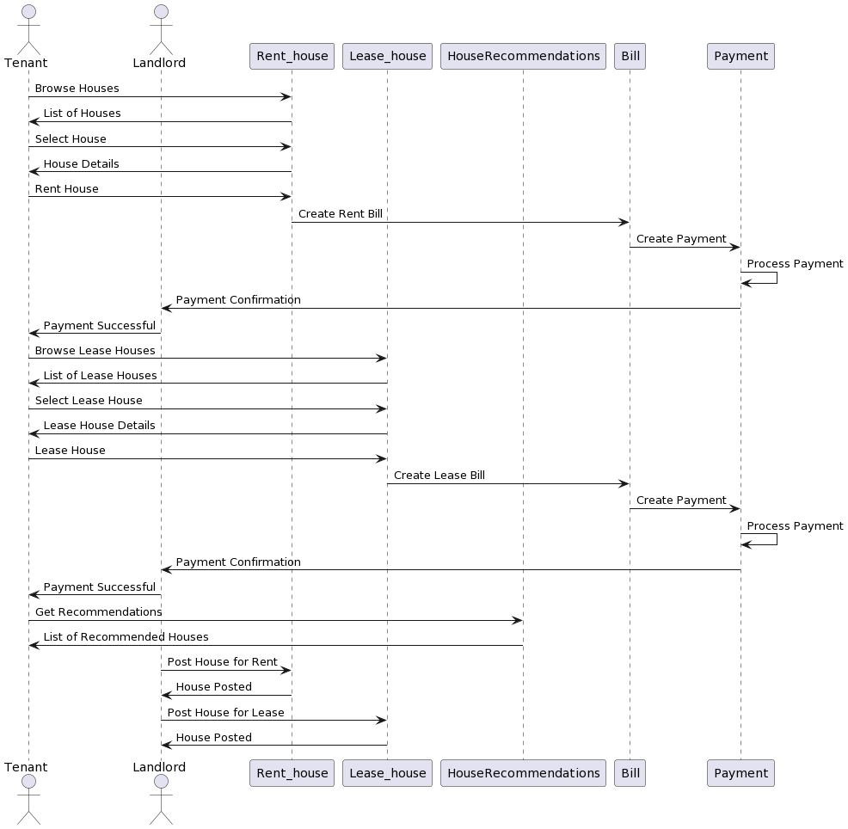

1. **Test Cases**

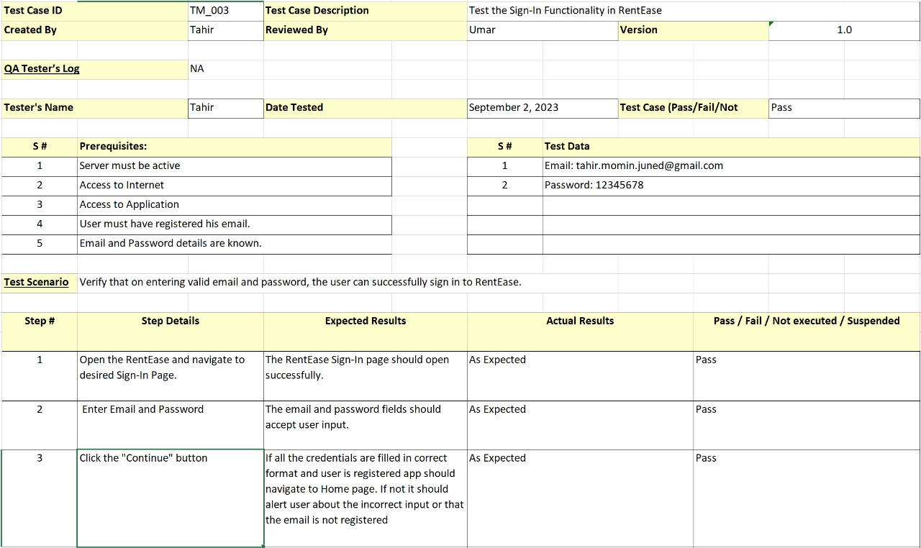

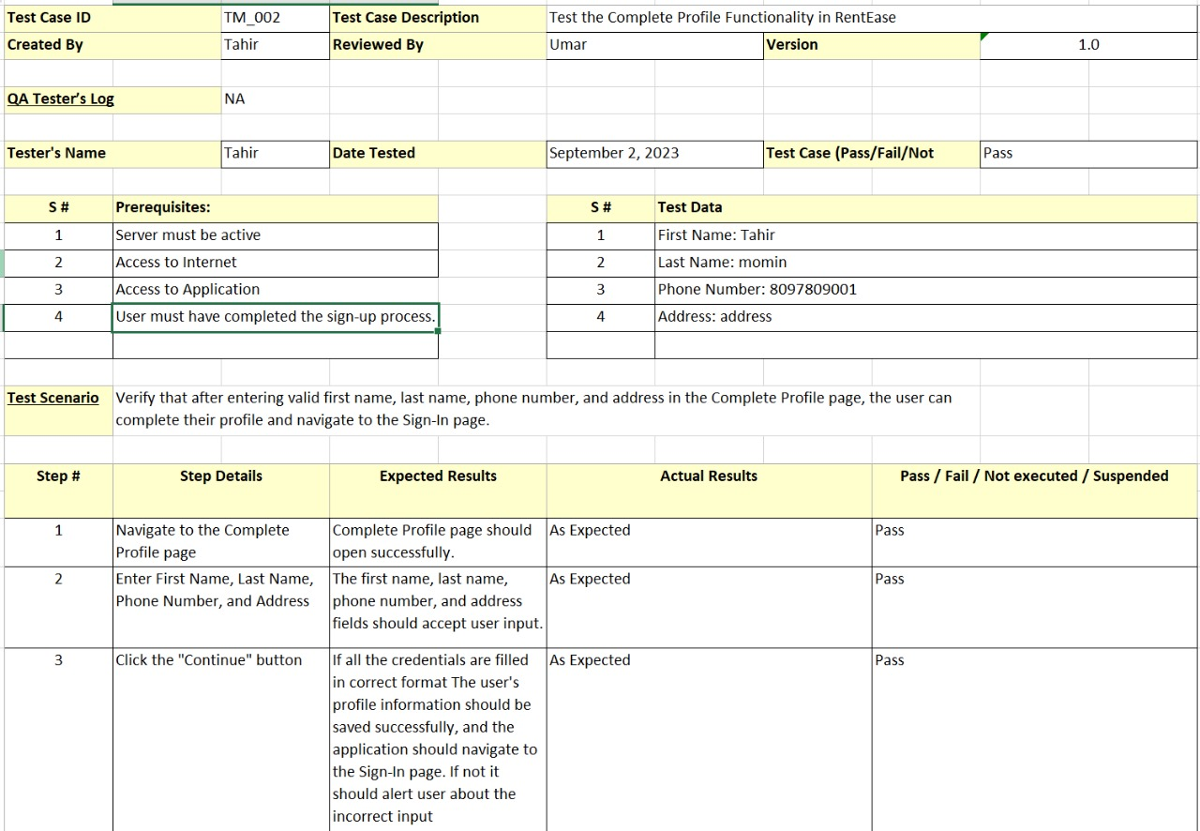

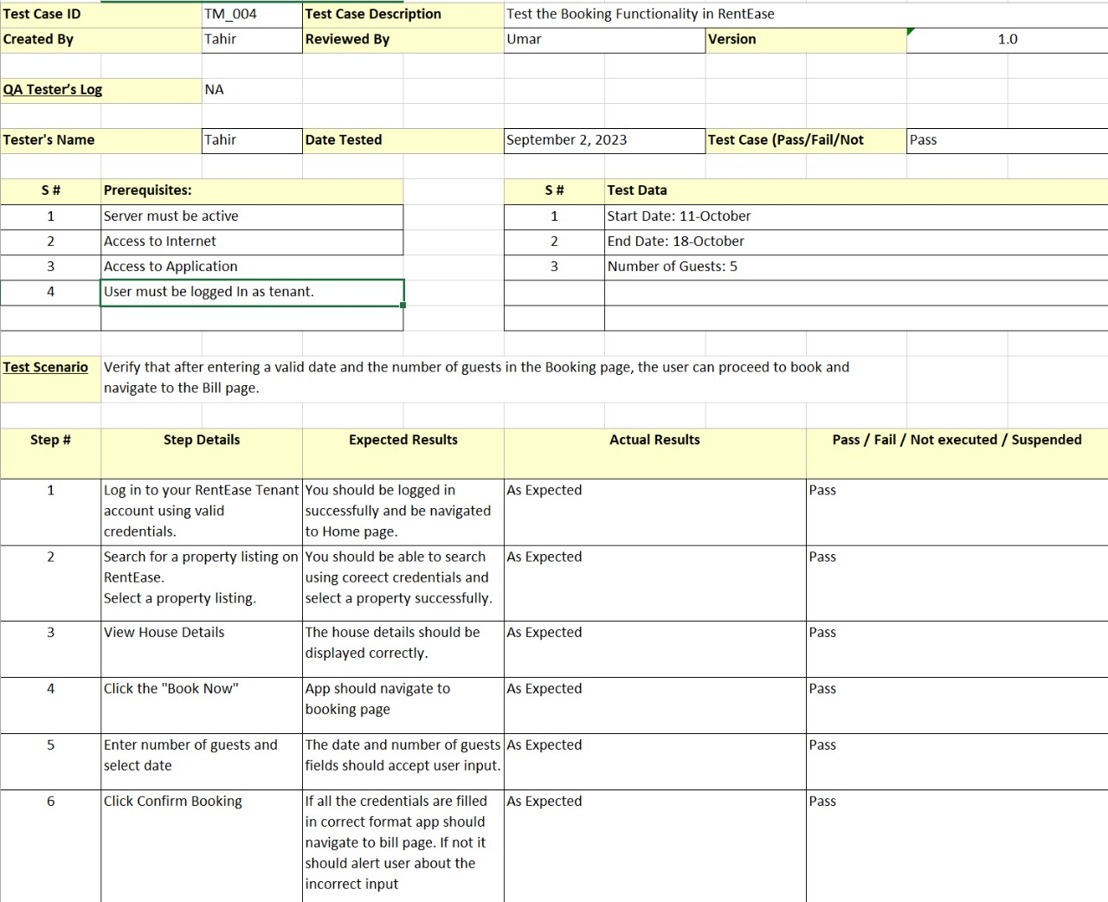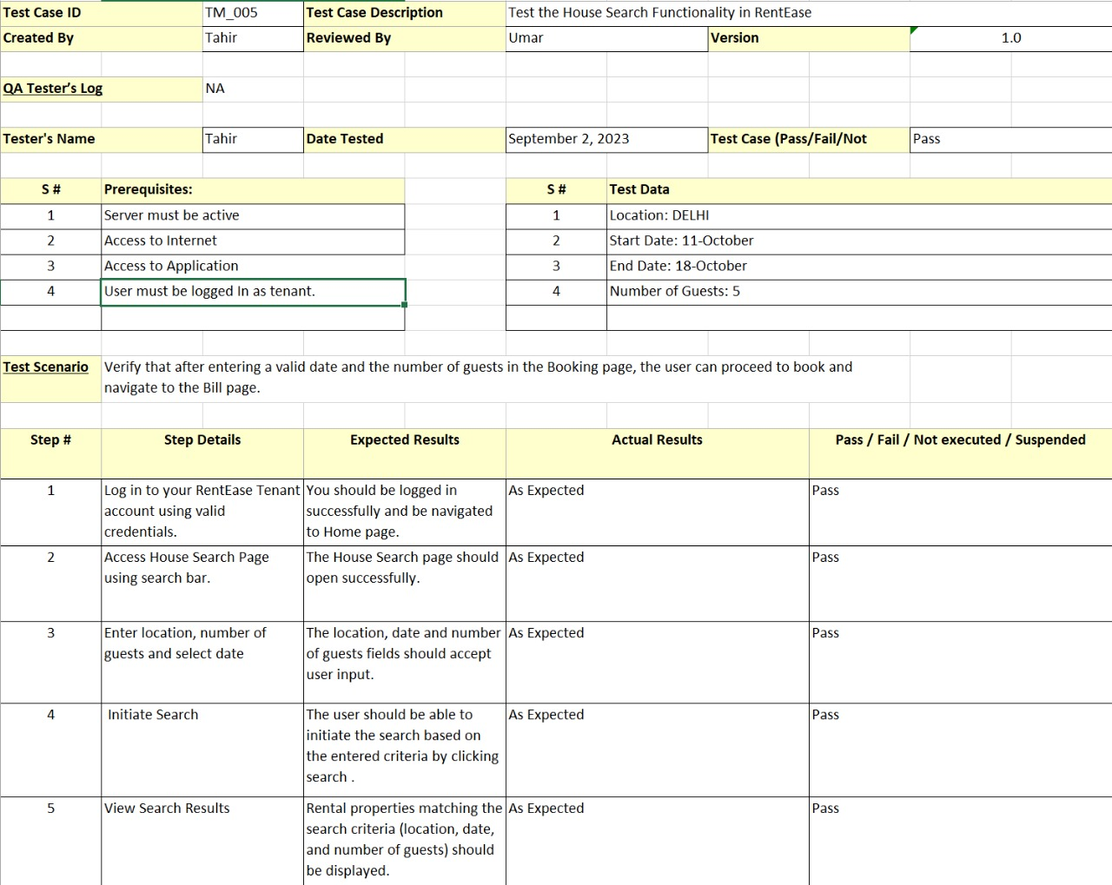

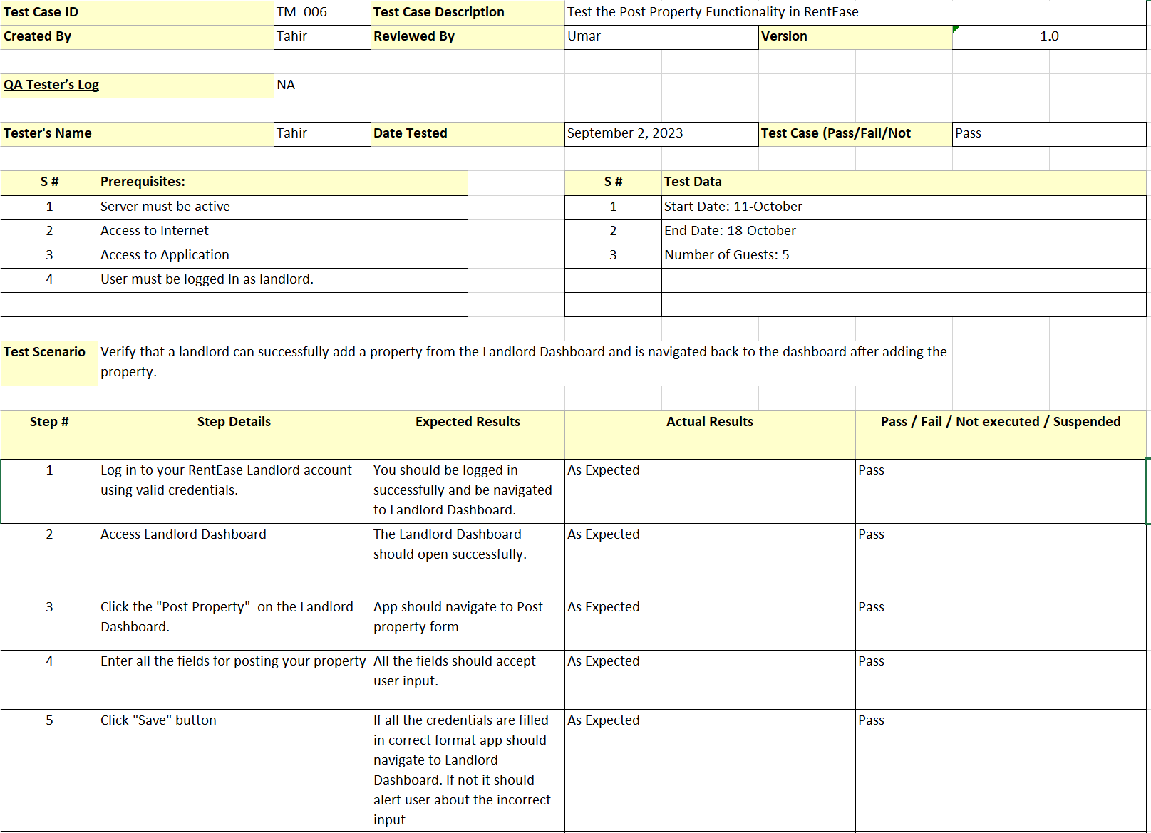

1. **Reports**

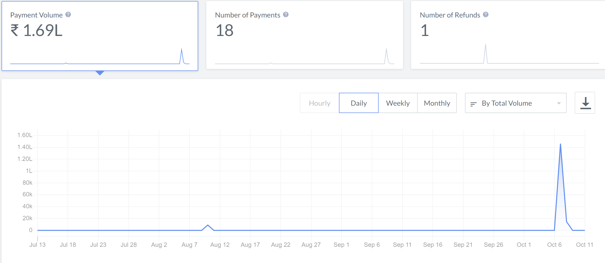 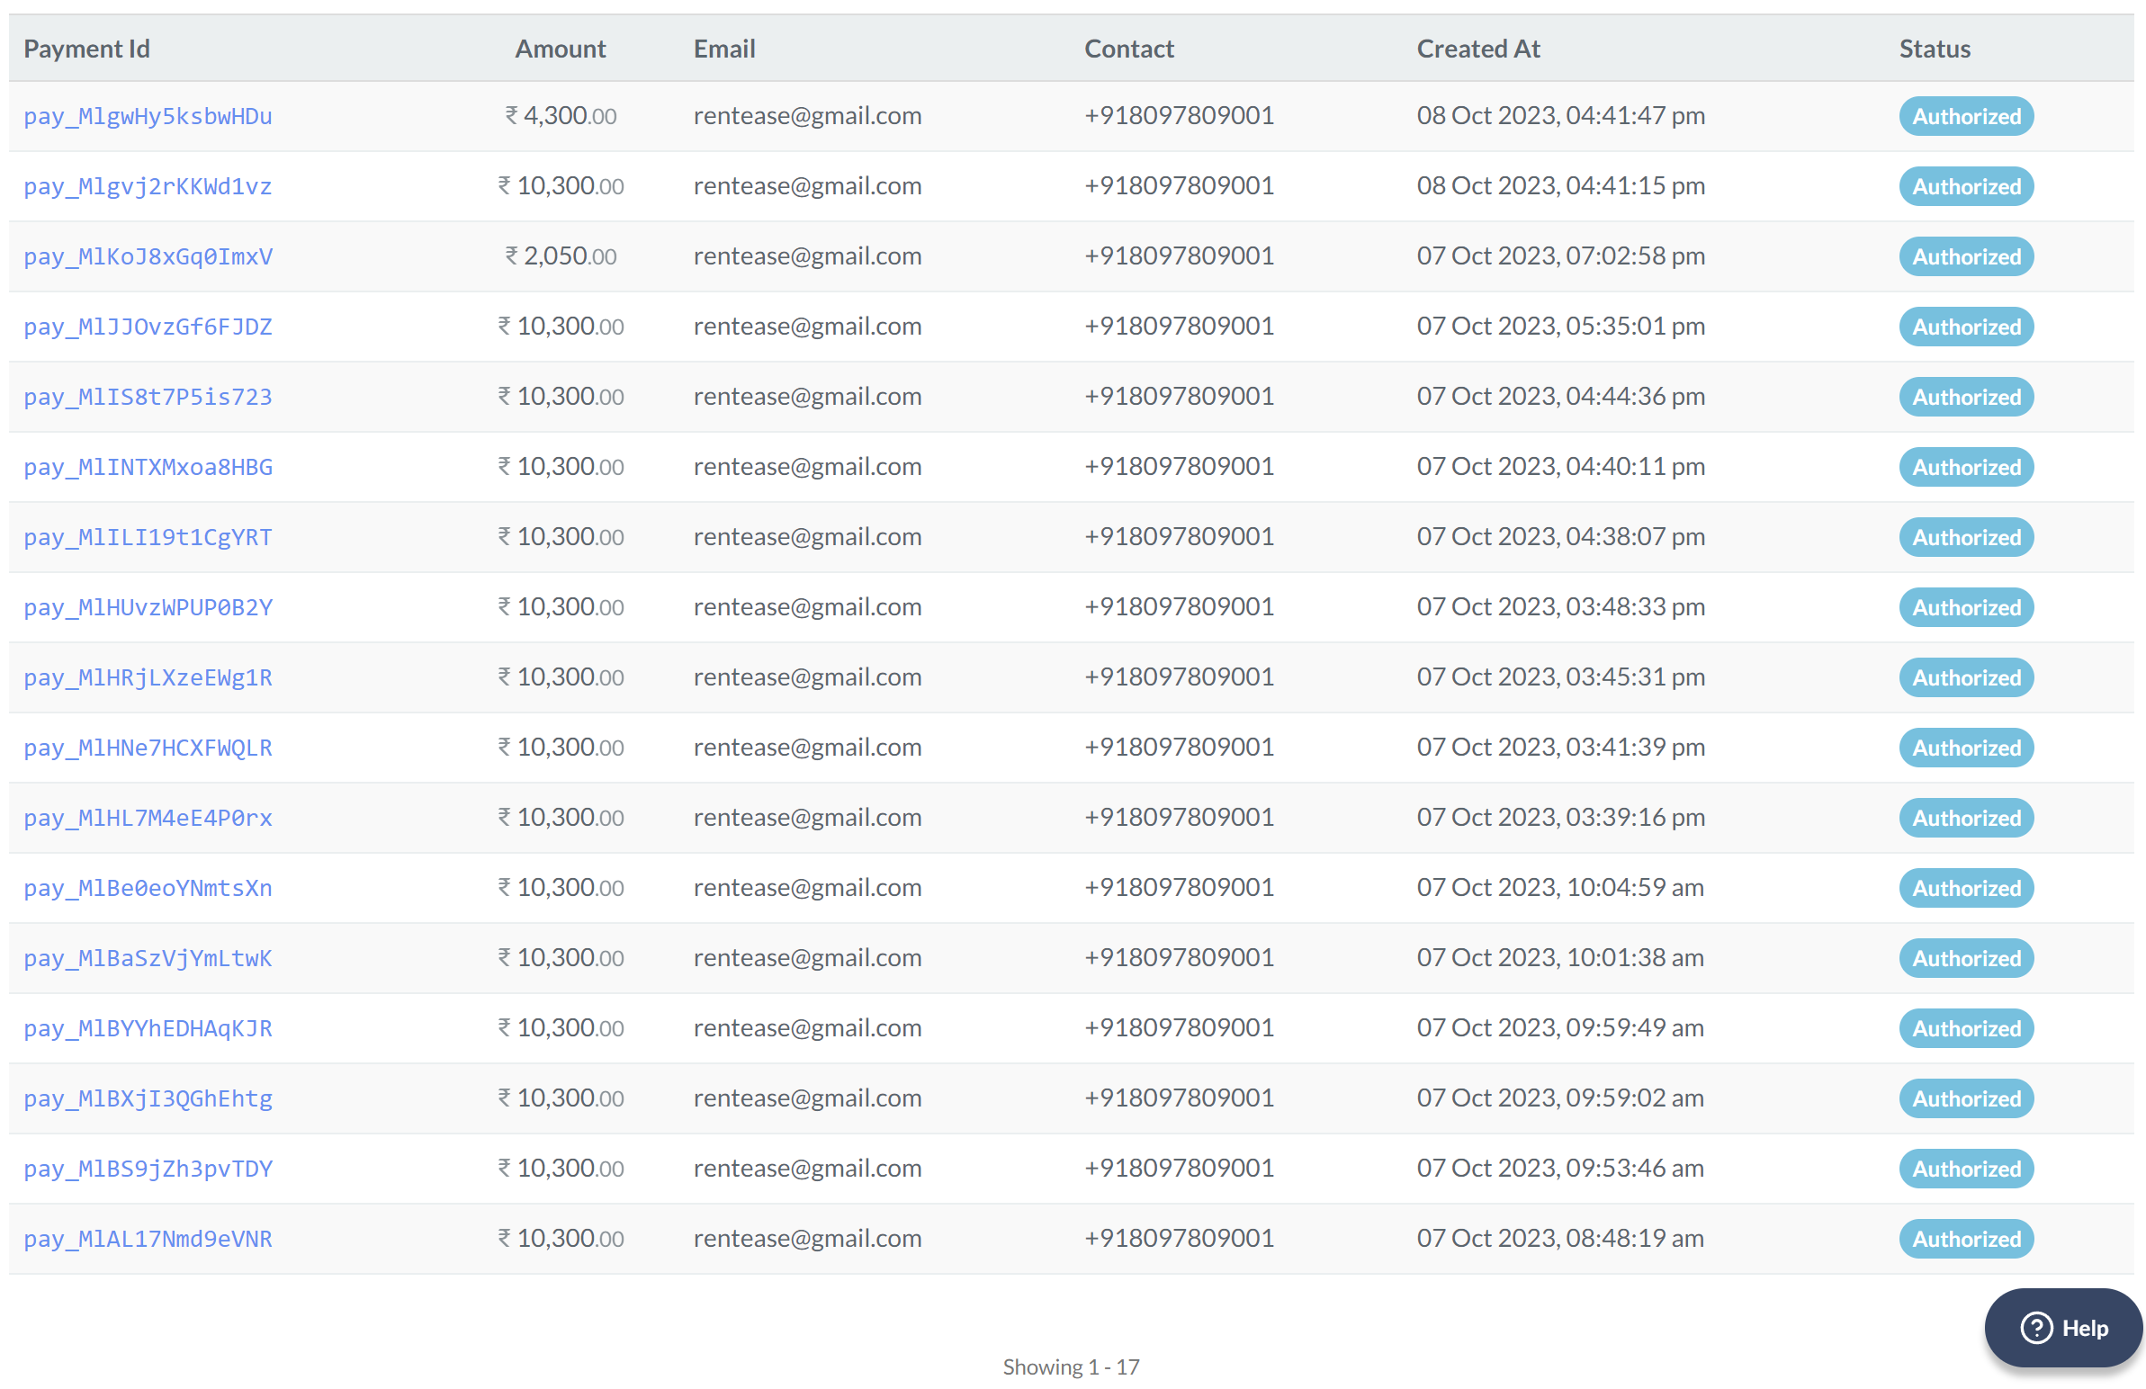 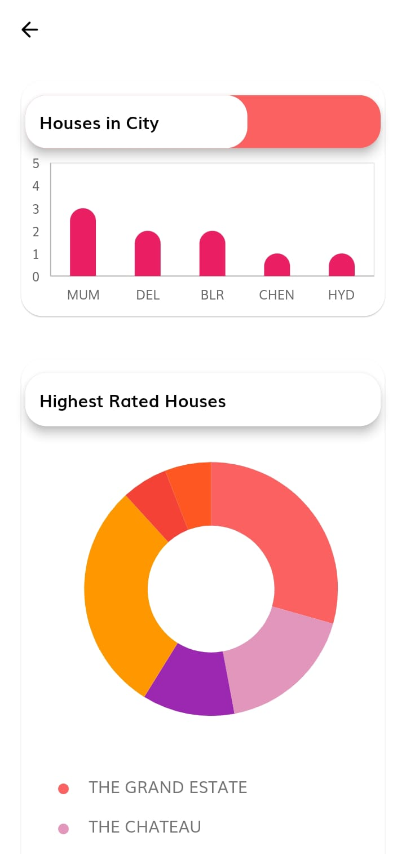

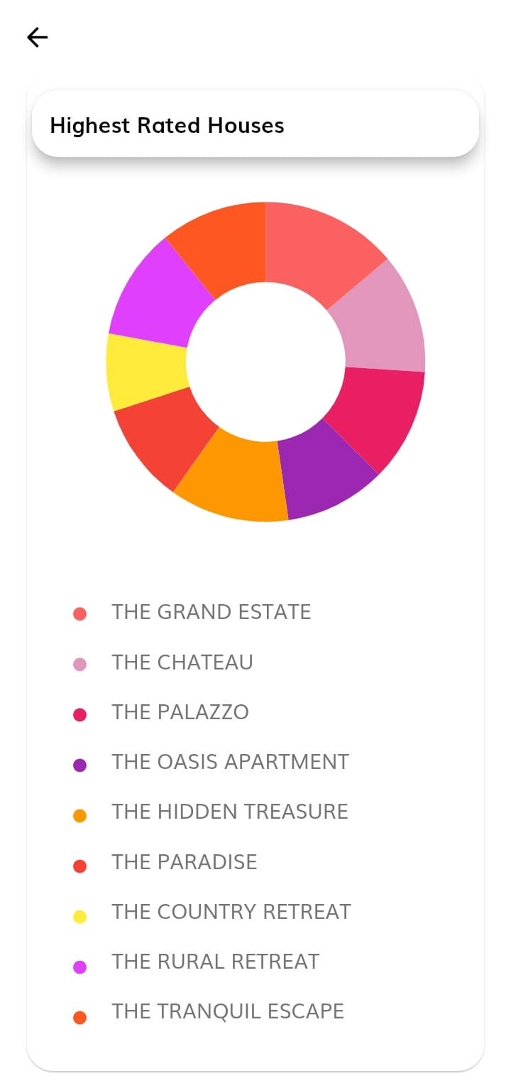 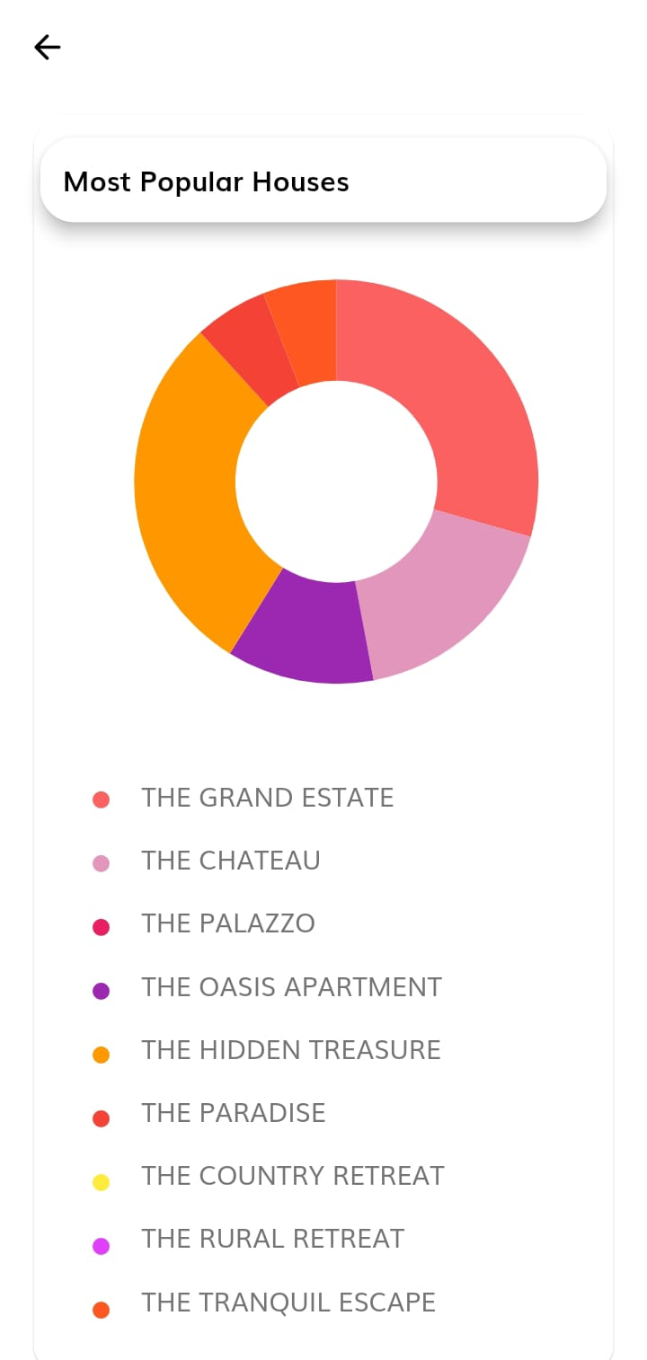

1. **UI Screen Shots**

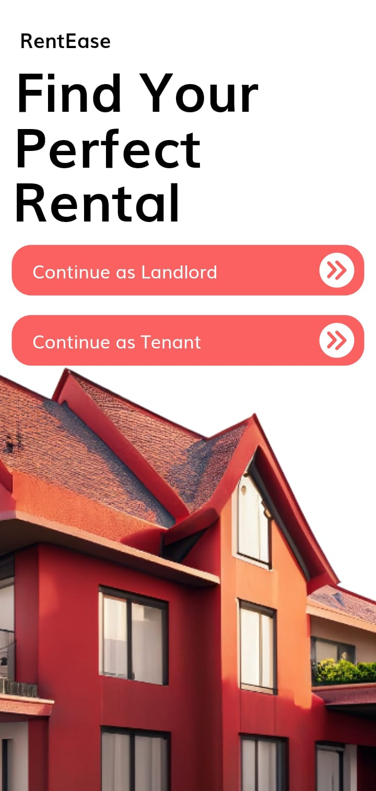 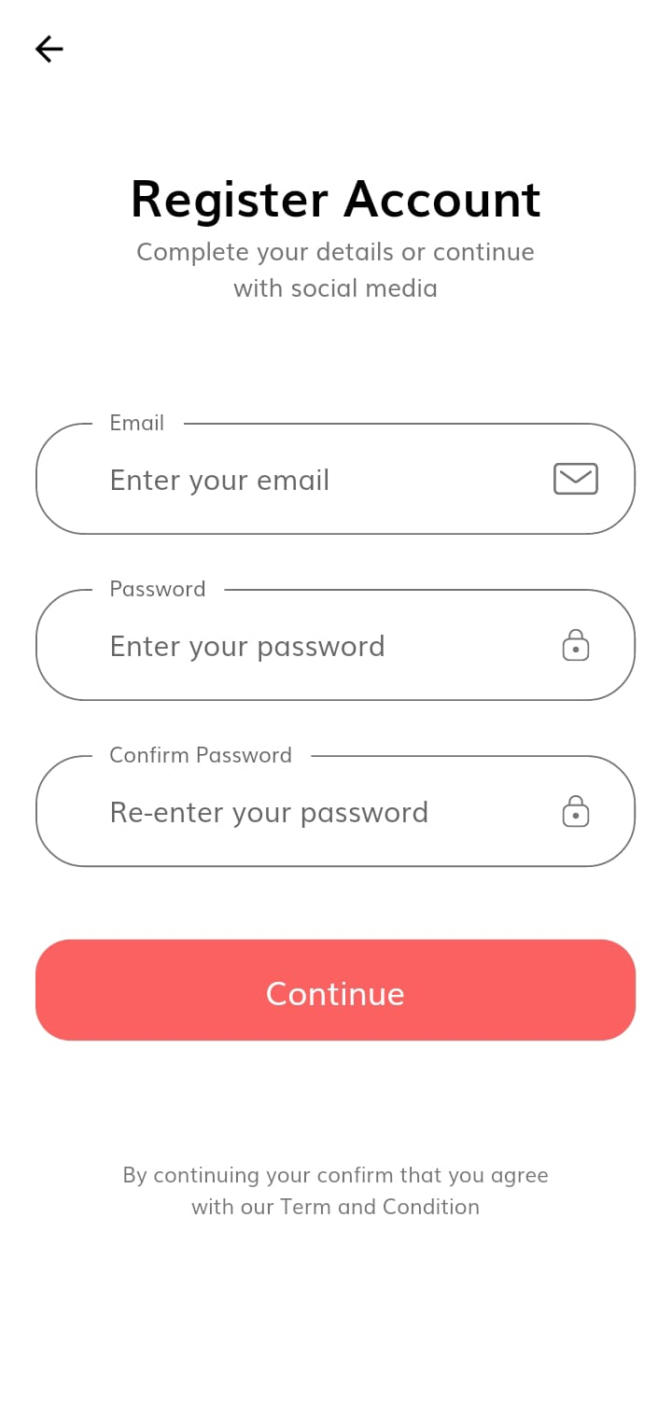

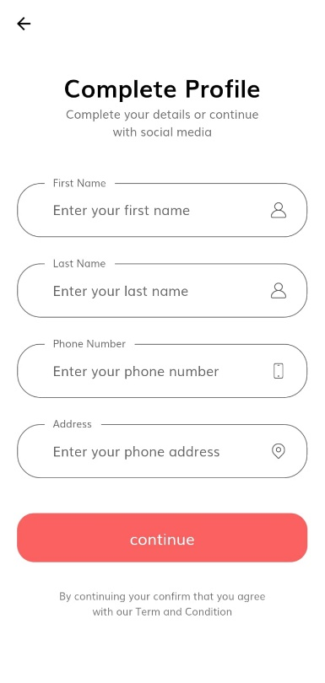 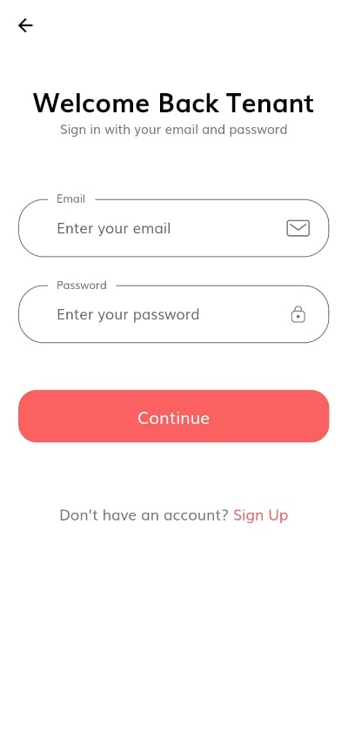

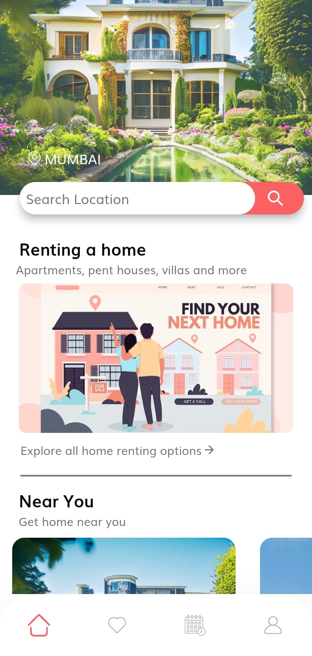 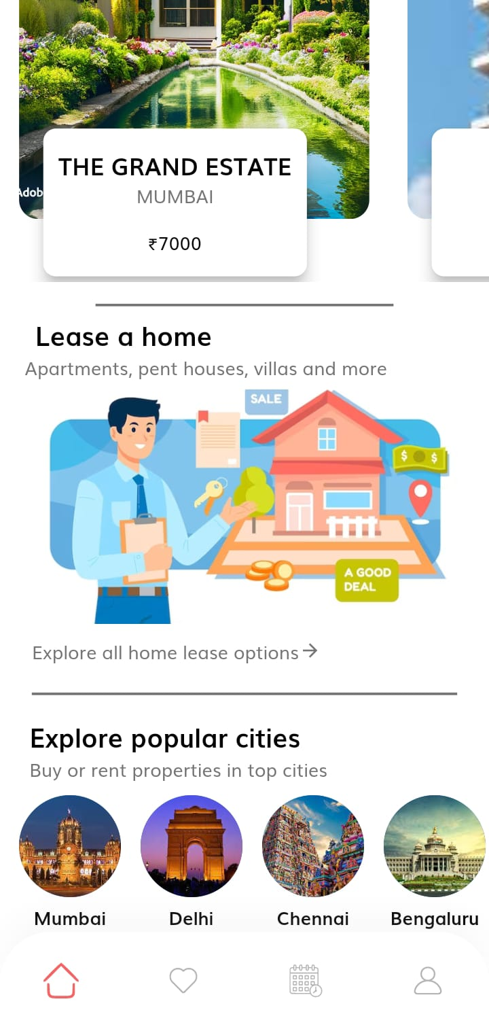

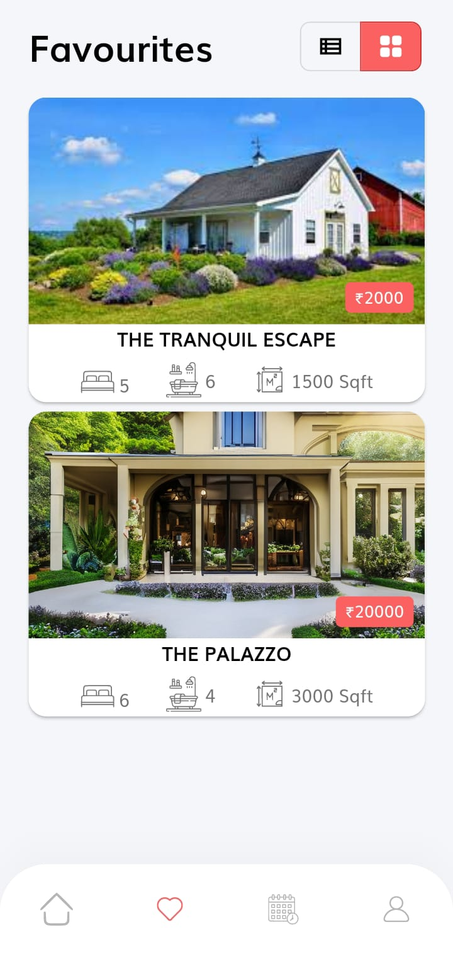 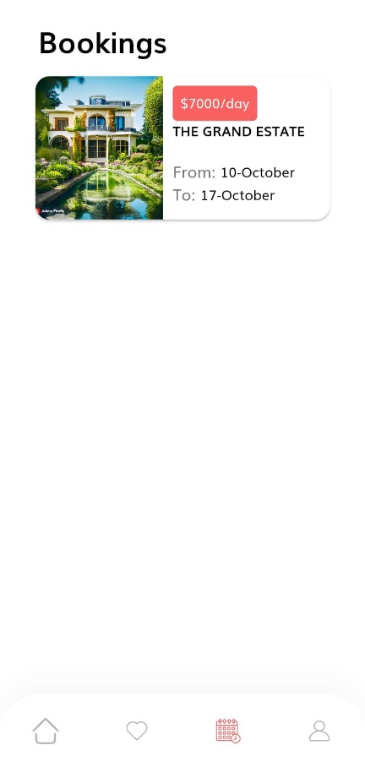

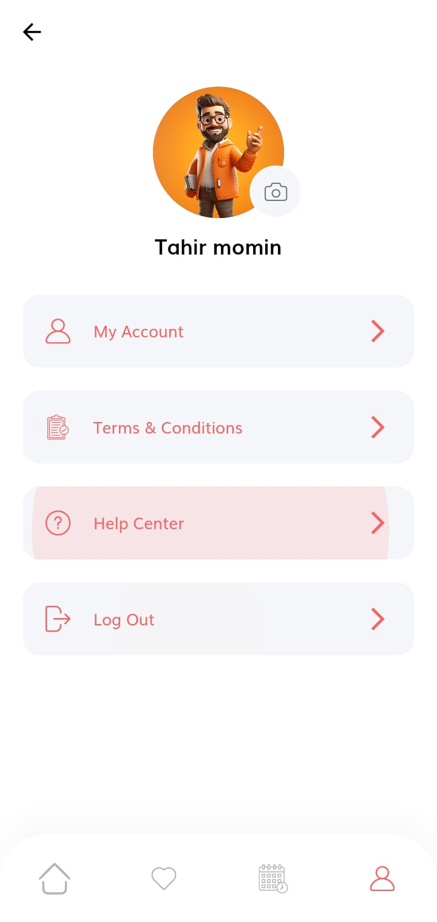 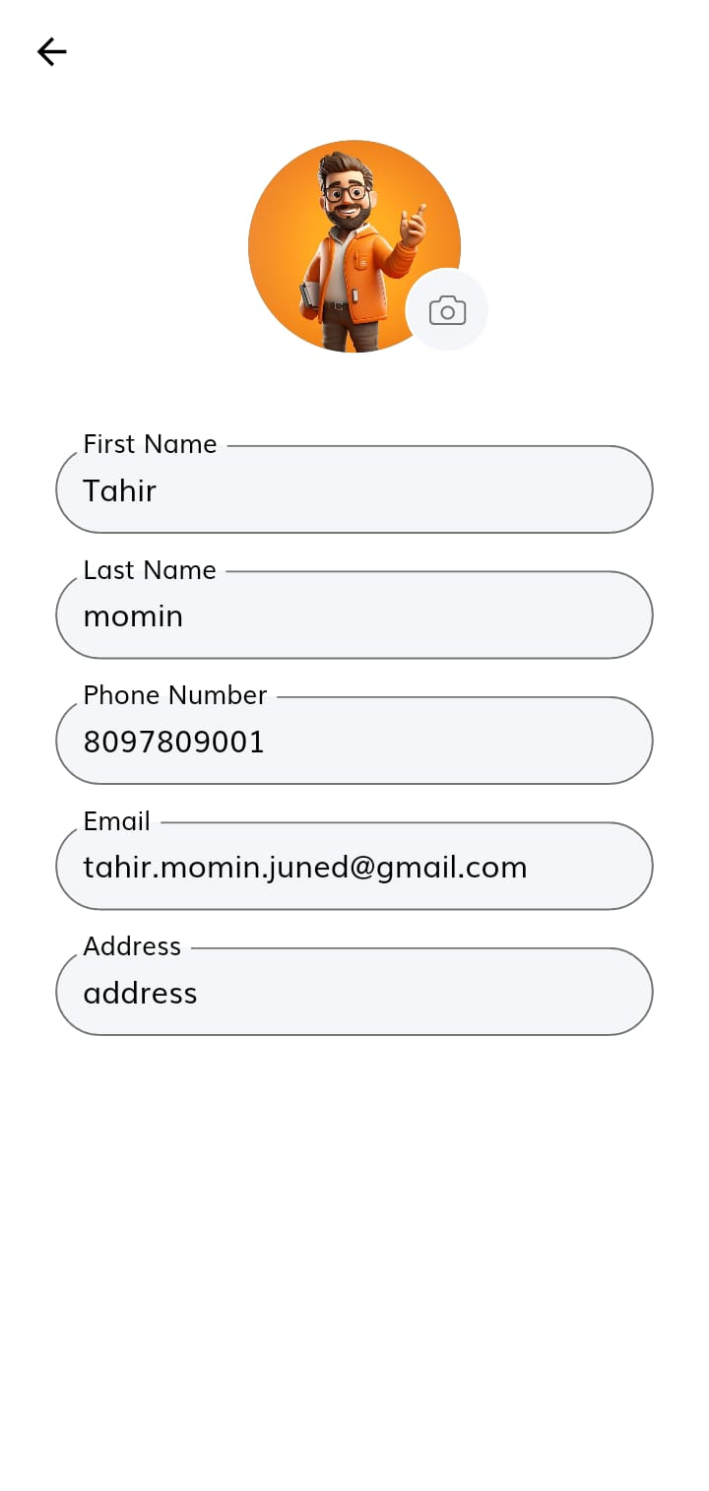

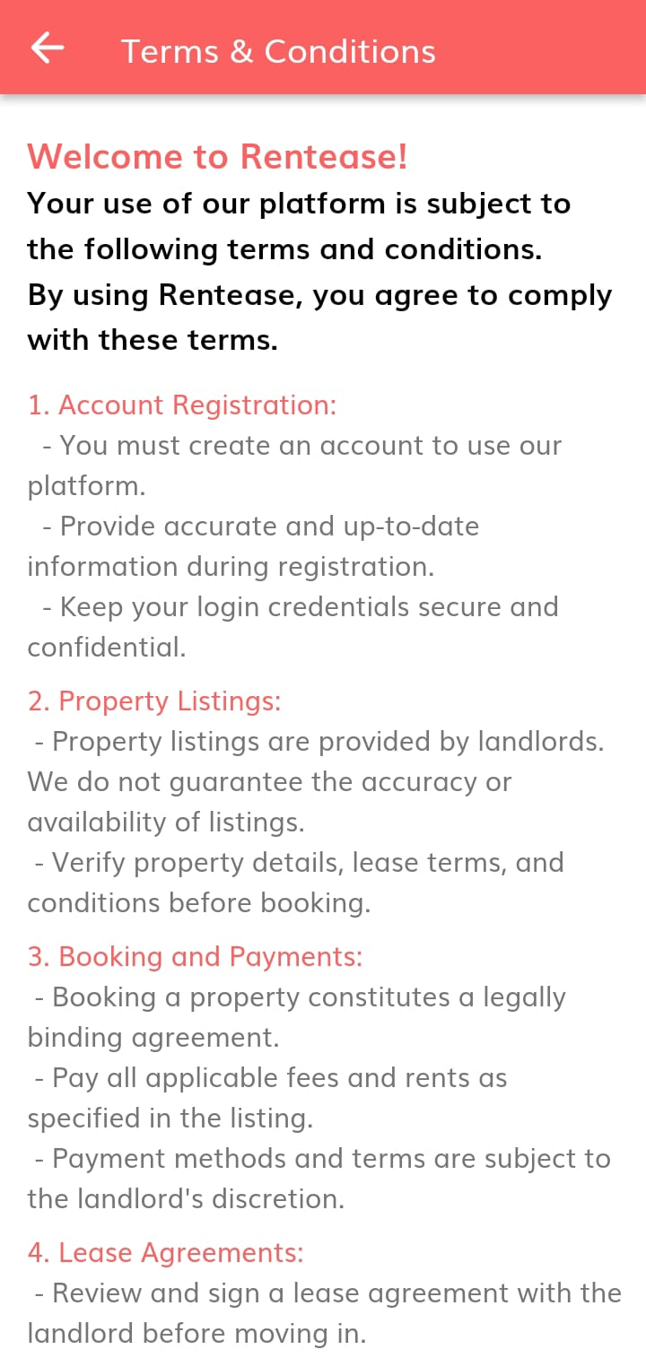 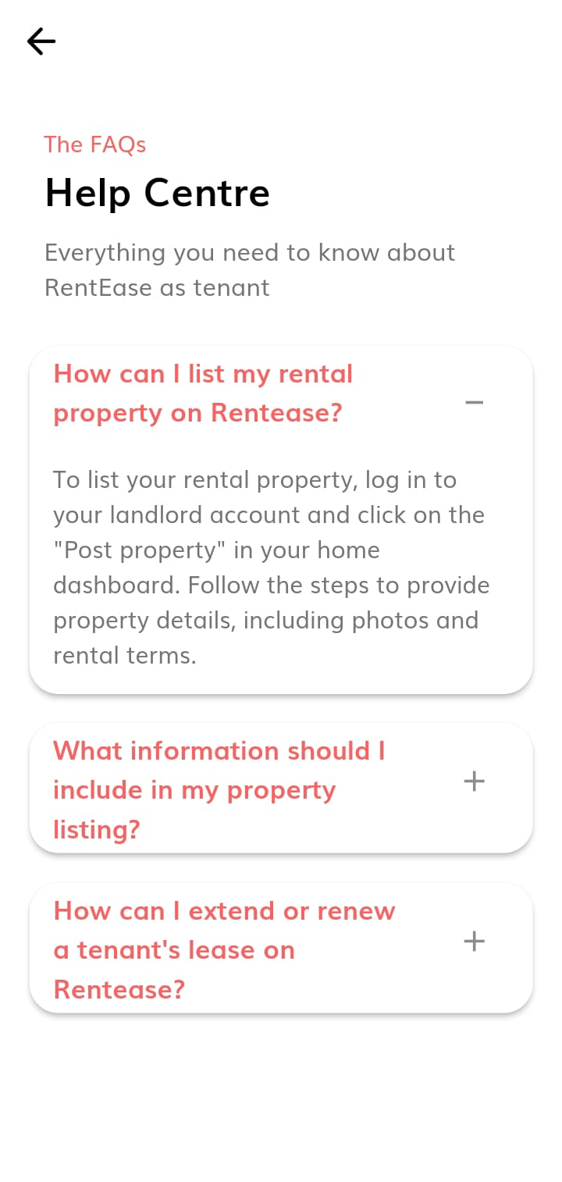

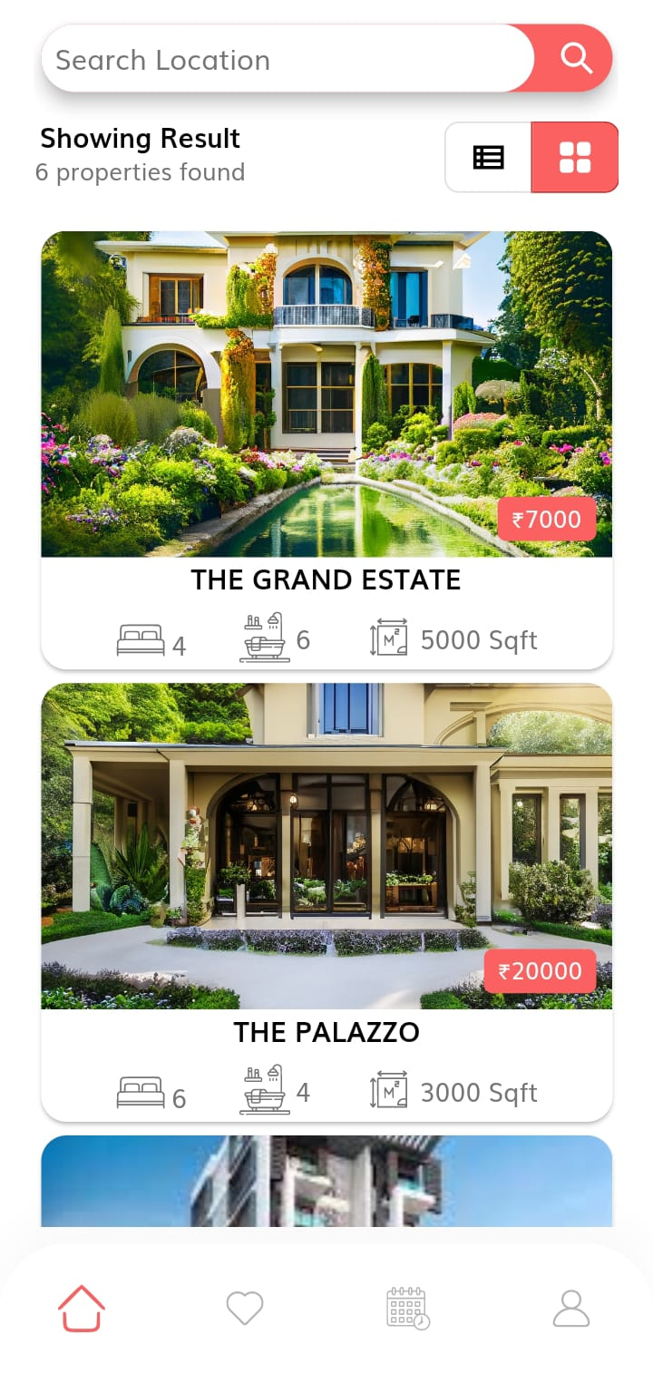 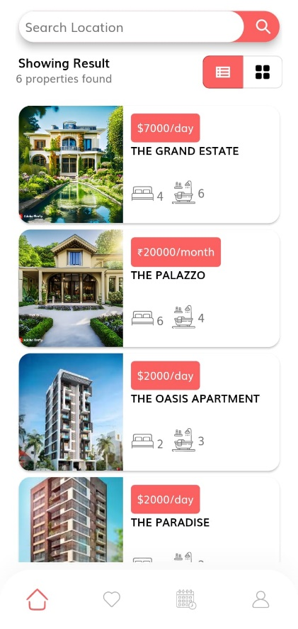

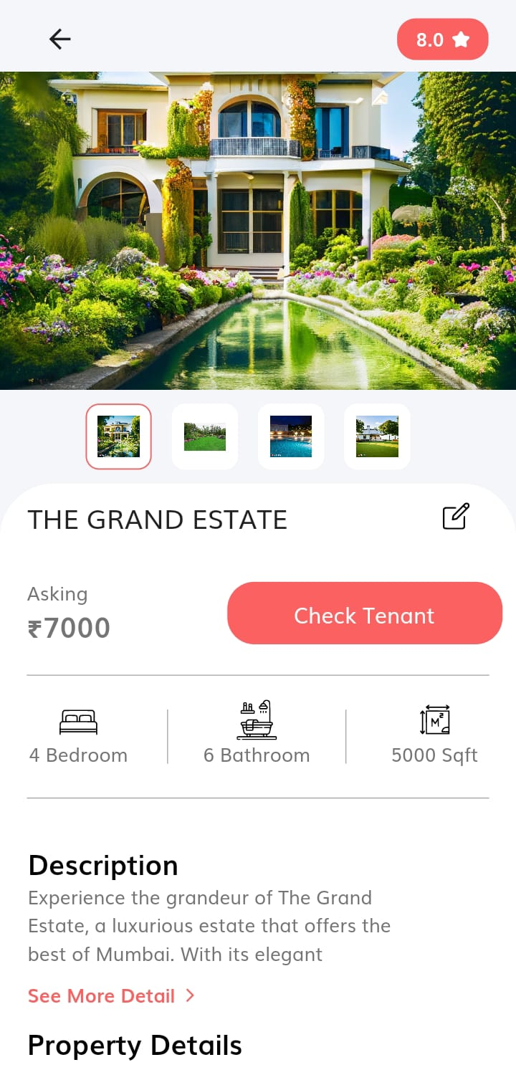 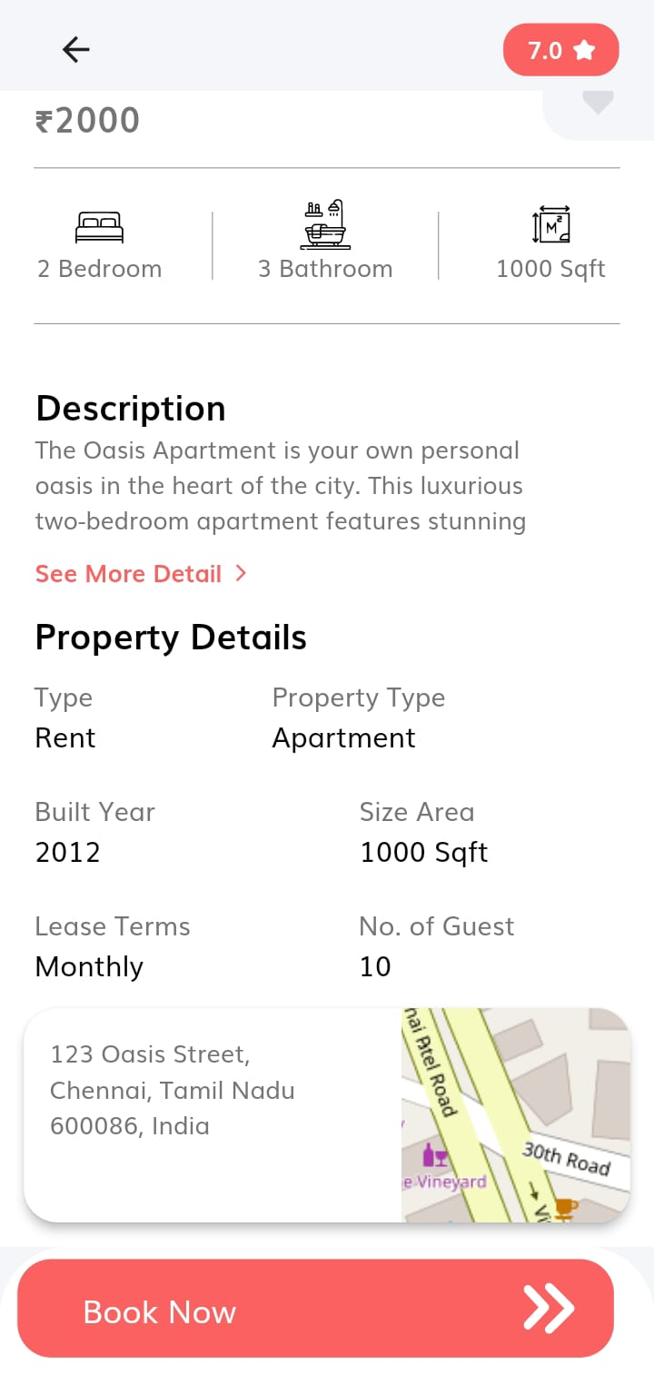

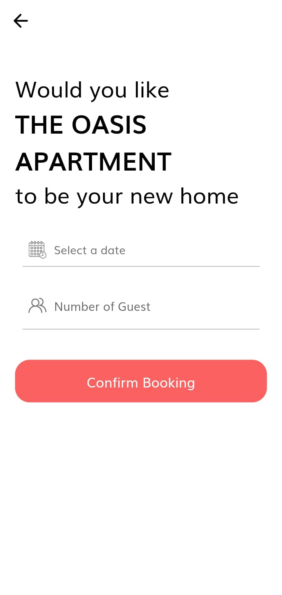 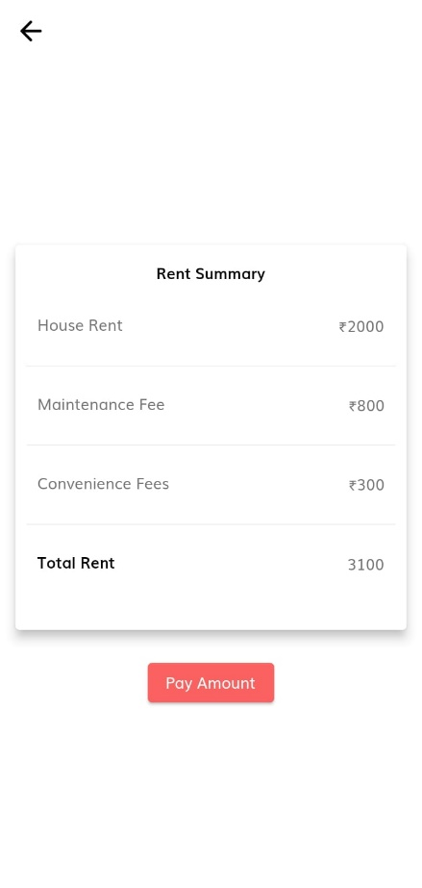

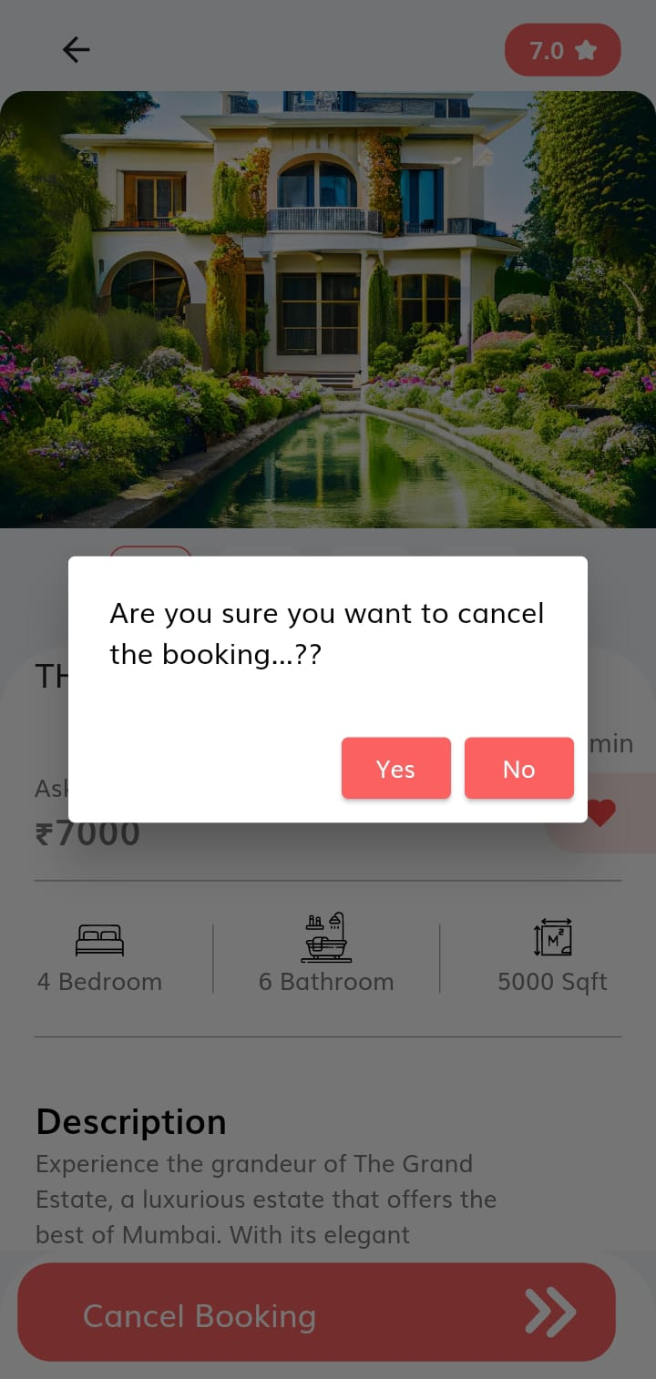 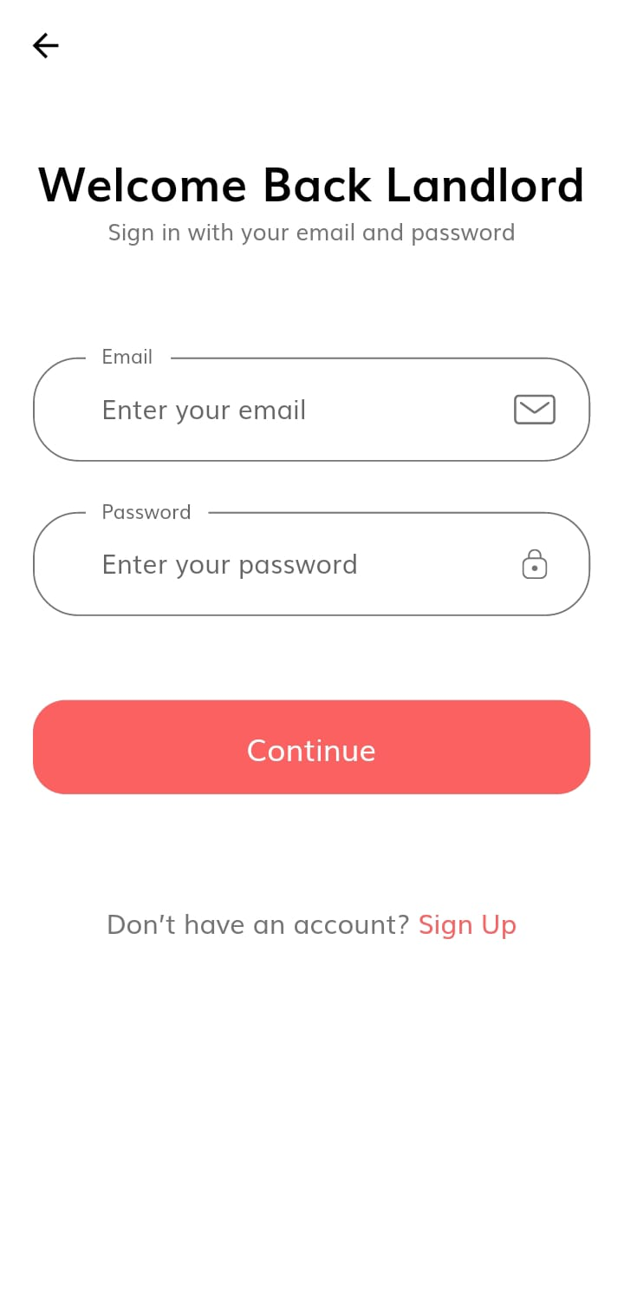

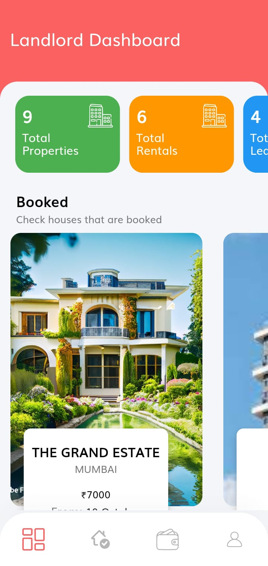 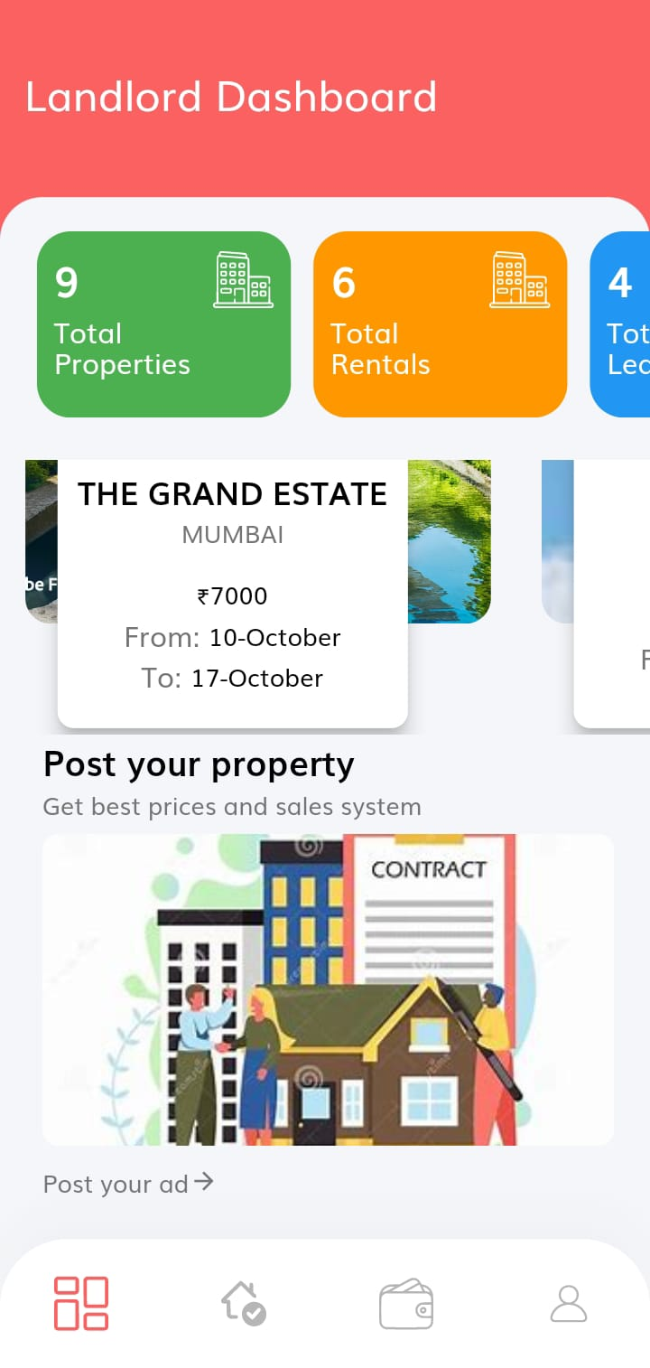

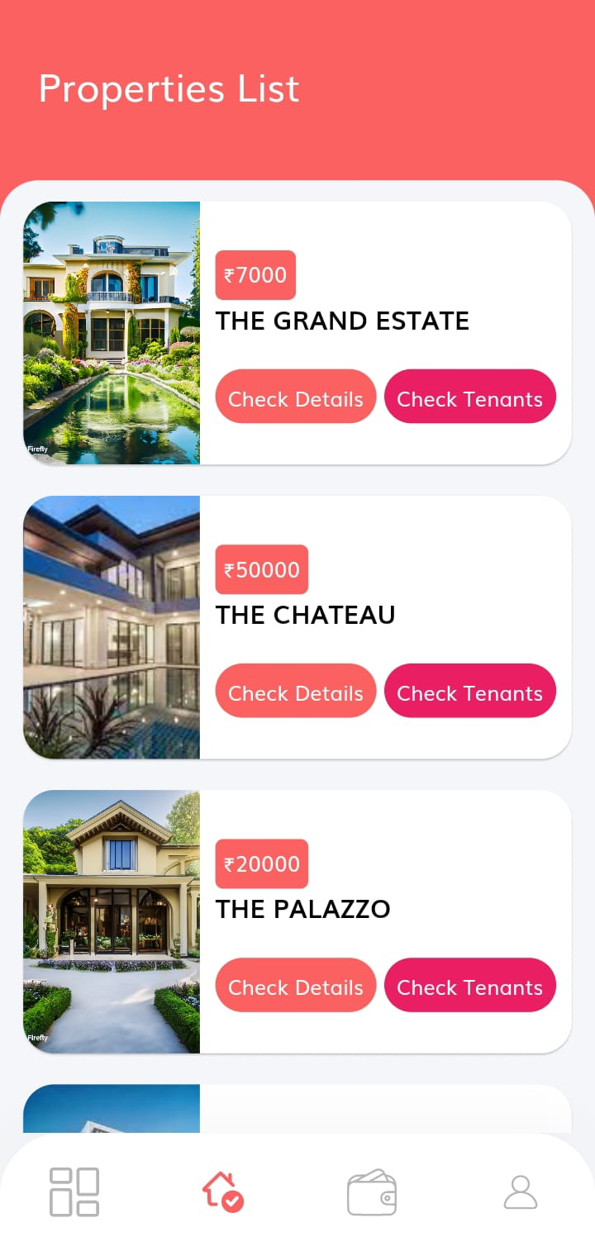 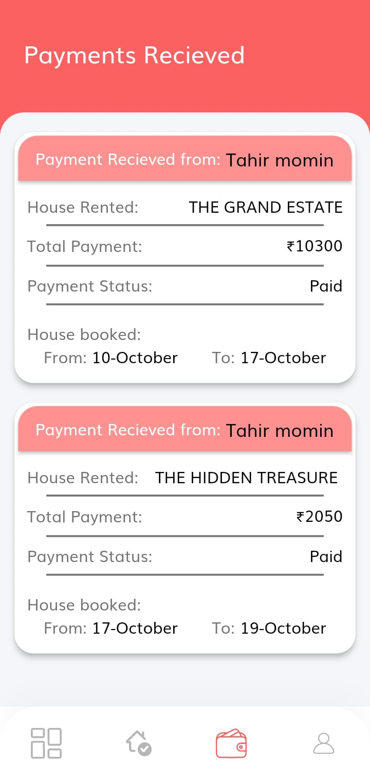

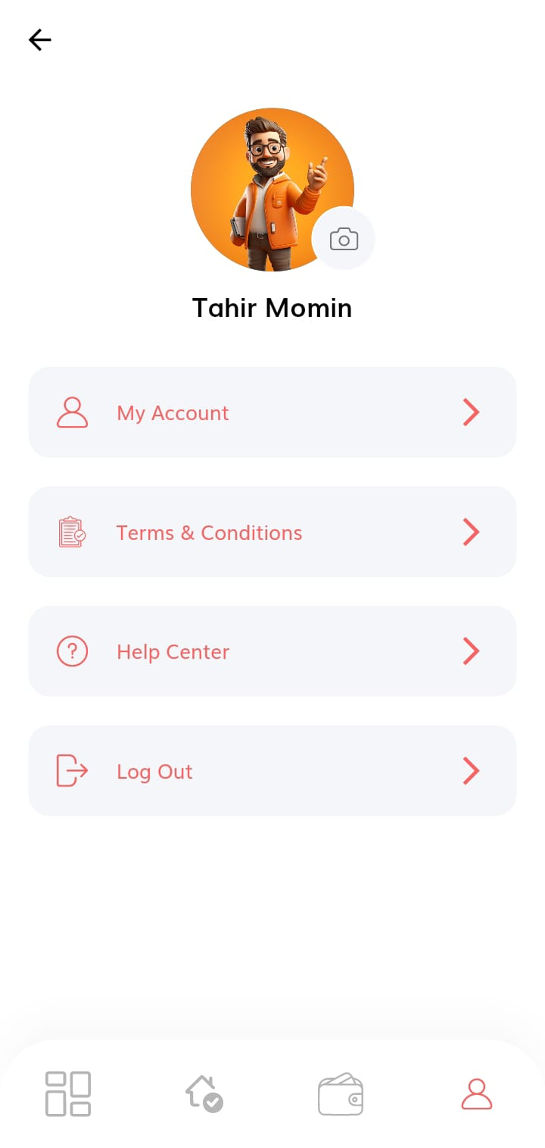 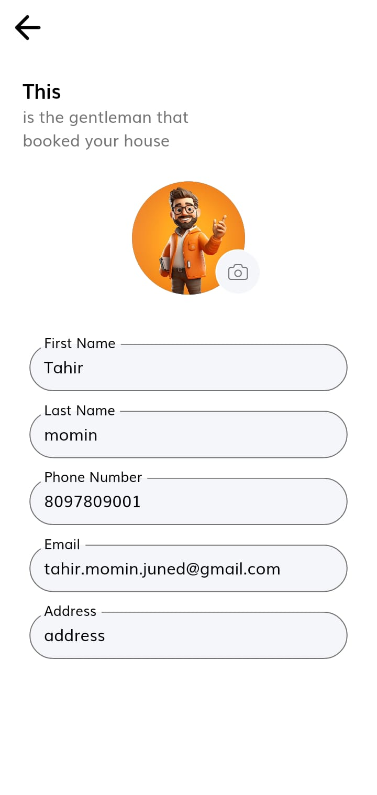

* *

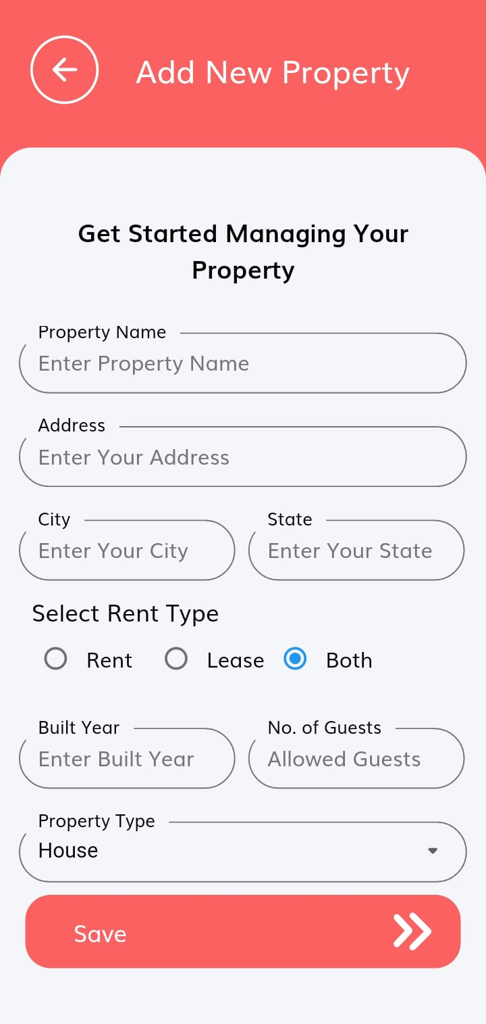 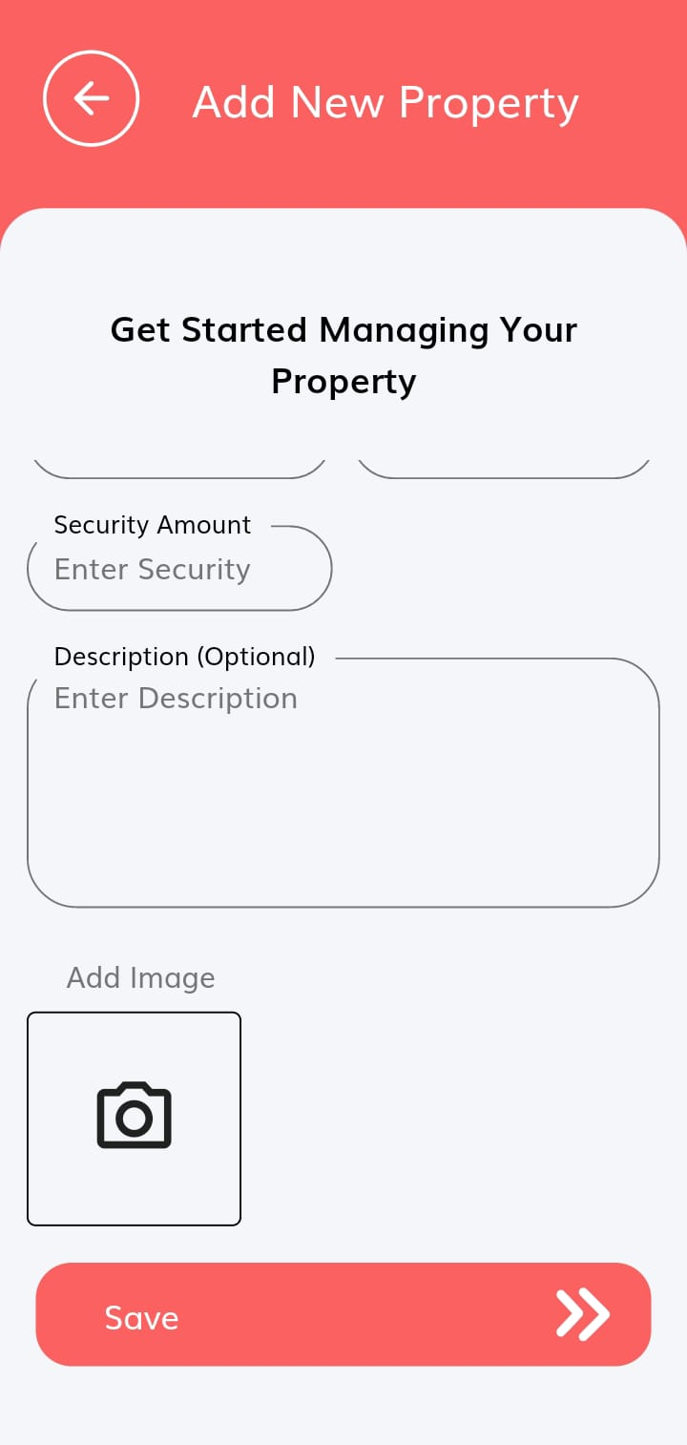

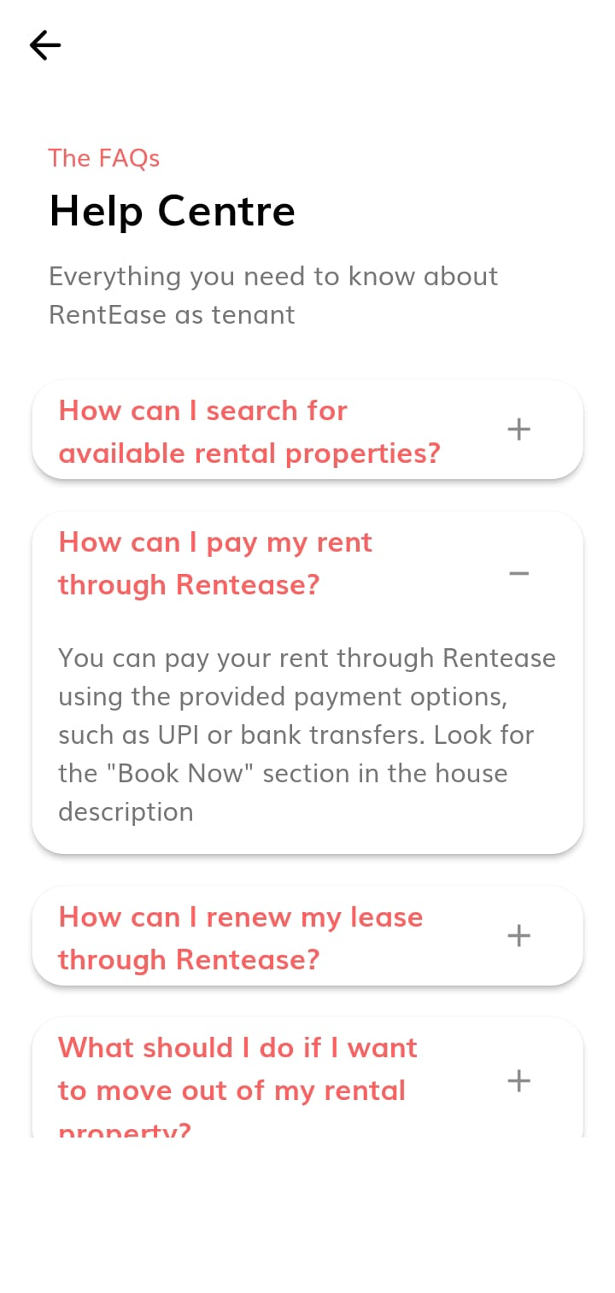

1. **Future Scope**

The future scope for RentEase is promising, with potential opportunities for expansion and improvement in various aspects of the platform. Here are some key areas of future scope for RentEase:

1. Geographical Expansion:

- RentEase can consider expanding its services to cover a wider geographical area, both nationally and internationally. This expansion would open up new markets and increase the user base.

2. Property Types and Categories:

- Expanding the types of properties available on the platform, such as commercial properties, vacation rentals, or short-term accommodations, can attract a diverse set of users and property owners.

3. Advanced Search and Recommendation Algorithms:

- Implementing advanced search and recommendation algorithms can enhance the user experience. Machine learning and AI-driven algorithms can provide personalized property recommendations based on user preferences and behavior.

4. Virtual Reality (VR) Property Tours:

- Integrating VR technology to offer virtual property tours can revolutionize the way users explore rental properties. Users can virtually walk through properties from the comfort of their homes, saving time and effort.

5. Property Management Tools:

- Developing property management tools for landlords to efficiently manage their rental properties, including maintenance requests, rent collection, and financial tracking, can add significant value to the platform.

6. Payment Features and Financial Services:

- Expanding financial services within the platform, such as rent payment processing, financial planning tools, and insurance options, can make RentEase a comprehensive solution for both tenants and landlords.

7. Blockchain and Smart Contracts:

- Integrating blockchain technology for secure and transparent lease agreements through smart contracts can reduce disputes and enhance trust between parties.

8. Sustainability and Green Housing:

- Promoting and listing environmentally sustainable and energy-efficient properties can align with the growing trend of eco-conscious living.

9. Community Features:

- Creating a community or social networking aspect within the platform where users can share experiences, tips, and advice related to renting can foster a sense of belonging and engagement.

10. Data Analytics and Insights:

- Enhancing data analytics capabilities can provide users with valuable insights into rental trends, pricing dynamics, and neighborhood information, aiding in informed decision-making.

11. Enhanced Security and Privacy:

- Continuously improving security measures to protect user data and privacy is crucial in maintaining user trust. This includes robust identity verification and data encryption.

12. Partnerships and Integrations:

- Collaborating with real estate agencies, property management companies, financial institutions, and other service providers can expand the range of services available on the platform.

14. Regulatory Compliance:

- Keeping abreast of evolving rental and real estate regulations and ensuring RentEase complies with them is essential for long-term sustainability.

15. User Feedback and Continuous Improvement:

- Actively seeking user feedback and making continuous improvements based on user suggestions and needs is fundamental to staying competitive and user-centric.

16. AI-Powered Predictive Analytics:

- Utilizing predictive analytics and AI to forecast rental market trends, helping users make informed decisions about when and where to rent.

17. Localized Content and Language Support:

- Offering localized content and language support to cater to international markets and non-English-speaking users.

RentEase's future success lies in its ability to adapt, innovate, and meet the evolving needs of both renters and property owners. By embracing these future scopes, RentEase can solidify its position as a leading rental platform in the real estate industry.

**10. Conclusion**

In conclusion, RentEase stands as a transformative force in the world of house rentals, offering a user-centric platform that streamlines the entire rental journey for both tenants and landlords. With a commitment to user convenience, security, and transparency, RentEase has redefined the rental experience, setting a new standard in the industry.

One of RentEase's key strengths is its comprehensive approach to rental management. Through its well-designed modules, including User, Admin, and Landlord functionalities, RentEase ensures a seamless and efficient process from the initial property search to lease agreements and rental payments. Tenants can easily find their ideal rental properties, connect with landlords, and navigate the rental process with confidence, while landlords benefit from simplified property management tools.

What sets RentEase apart is its dedication to innovation. The incorporation of cutting-edge technologies like Flutter, Dart, Node.js, Express, and SQLite3 provides a robust and scalable foundation for the platform. Moreover, RentEase embraces artificial intelligence to offer personalized property recommendations, virtual property tours, and even blockchain-based smart contracts, opening up exciting possibilities for the platform's continued growth and improvement.

As RentEase looks toward the future, its scope remains promising. The potential for geographical expansion presents opportunities to serve a broader audience. Advanced search algorithms will enhance user experiences by ensuring more accurate property matches. Sustainability initiatives will align RentEase with eco-friendly practices, contributing to a greener planet. Community-building features will foster connections among users, creating a sense of belonging within the RentEase community.

Above all, RentEase places a premium on user satisfaction. The platform continuously seeks feedback and actively implements improvements to meet the ever-changing needs of its diverse user base. The unwavering commitment to security, convenience, and innovation sets RentEase apart, making it an indispensable tool for anyone embarking on the journey of finding or renting a home.

In the competitive landscape of rental platforms, RentEase shines as a beacon of user-centricity, innovation, and efficiency. It has not only simplified house rentals but also set a high standard for the entire industry. With RentEase, the future of house rentals is brighter than ever, offering a promising and transformative rental experience for all.

**11. Bibliography**

• **Tutorials and Documentation:**

* + - GeeksforGeeks - geeksforgeeks.org/flutter-tutorial
    - TutorialsPoint - tutorialspoint.com/dart
    - W3Schools - w3schools.com/Django

• **Official Documentation:**

* Node JS - https://nodejs.org/docs/
* Express JS - https://expressjs.com/
* Sqlite3 - https://www.sqlite.org/docs.html

• **Flutter Documentation**

* flutter.dev/docs

• **Dart Documentation**

* dart.dev/guides

• **Forums and Communities:**

* Stack Overflow - stackoverflow.com/questions/tagged/flutter
* Reddit - reddit.com/r/dartlang
* GitHub - github.com/djangorsestframework/Django

• **Blogs:**

* Dev.to - dev.to/t/flutter